Drought Climatology in Missouri:

# Introduction:

Every Missourian knows that drought can take a toll, whether on a backyard garden or a thousand-acre farm. Understanding the history and patterns of drought throughout the state is a powerful tool, and while it may not be as effective as making it rain, it does allow us to make more informed decisions. This report utilizes a 24-year drought climatology based on the University of Missouri and the Missouri Climate Center’s weather station network.

## What is drought?

Drought, as an overarching term, is defined as “a period of dryness especially when prolonged” (Merriam-Webster, n.d., Definition 1). This, however, is not nuanced enough for our purposes. Instead of using the overarching definition, it is best to define drought in distinct categories. The National Weather Service classifies drought into the following categories.

* Meteorological Drought: Based solely on the amount of rainfall that has occurred in a region over a given period. The less rainfall, the more severe the drought.
* Hydrological Drought: Based on the impact that meteorological drought has on a water supply. This could be a lake, stream, river, or other body of water.
* Agricultural Drought: Based on the impacts that both meteorological and hydrological drought may have on soil, irrigation, etc.
* Socioeconomic Drought: Based on the impacts of meteorological, hydrological, and agricultural drought on the supply and/or demand of goods that depend on water for production. Fruits, vegetables, grains, meat, etc. The National Weather Service explicitly defines this as: “when the demand for an economic good exceeds supply as a result of a weather-related deficit in water supply” (US Department of Commerce, 2018).

## For the purposes of this study, we will exclusively examine meteorological drought. This is because we will be using precipitation data exclusively. It is worth noting that the impacts of precipitation deficits (meteorological drought) extend to hydrological, agricultural, and socioeconomic droughts (Wilhite & Glantz, 1985). In this way, the study will be useful for assessing all types of drought to some degree, but will only directly analyze meteorological drought. For more information on how drought was calculated, and the exact thresholds used for drought classification, go to the “Data and Methodology” section of this text (pg. 2).

## Why Understand Drought Climatology in Missouri?

Droughts, unfortunately, are common in the state and happen at all levels from meteorological to socioeconomic. From 1980 to 2024, Missouri experienced 16 droughts that each caused at least one billion dollars in damage, as reported by the NCEI Billion Dollar Disaster database (NOAA National Centers for Environmental Information, 2025). The examination of meteorological drought data can be used to mitigate its impacts, thereby lessening downstream hydrological, agricultural, and socioeconomic impacts (Wilhite & Glantz, 1985). For example, the seasonality of drought is important for agricultural communities to know, as it indicates whether drought onset is becoming a “new normal” each growing season. Precipitation deficits are also an early indicator of the impacts that agricultural and hydrological droughts bring (National Integrated Drought Information System). By emphasizing precipitation, we can better predict and understand the stresses that meteorological drought applies.

## Objectives of this study:

The objective of this study is to examine the history of droughts in Missouri over the past 24 years, analyzing their frequency, duration, severity, and identifying any patterns that can help predict droughts. We will use Missouri Mesonet data to examine drought characteristics and share our findings here, to be used by the public and researchers alike to better understand Missouri’s drought.

# Data and Methodology:

## Spatial and Temporal Coverage of Analysis:

The drought climatology analysis for the State of Missouri includes all Missouri Mesonet stations that have passed quality control checks. The following stations passed quality control and were used in the analysis:

|  |  |
| --- | --- |
| City | County |
| Albany | Gentry |
| Auxvasse | Audrain |
| Brunswick | Carroll |
| Cardwell | Dunklin |
| Charleston | Mississippi |
| Clarkton | Dunklin |
| Columbia-Sanborn Field | Boone |
| Columbia-South Farms | Boone |
| Cook Station | Crawford |
| Corning | Atchison |
| Delta | Cape Girardeau |
| Glennonville | Dunklin |
| Hayward | Pemiscot |
| Lamar | Barton |
| Linneus | Linn |
| Monroe City | Monroe |
| Novelty | Knox |
| Portageville | Pemiscot |
| St. Joseph | Buchanan |

The temporal coverage at every location listed above spans from January 1, 2000, to May 31, 2024. The raw data used in this study were formatted as daily precipitation. This was converted to monthly precipitation for the purposes of this study.

This 24-year period of record, although robust, is shorter than the standard 30-year period of record recommended for climatological studies (World Meteorological Organization, 2023). A 30-year period tends to do a good job of capturing and “smoothing out” extreme events in a way that is representative of an area's overall behavior. At 24 years, individual extreme events, or their absence, can significantly alter the results of the analysis. Therefore, while the period of record is sufficient for our purposes, it is essential to clarify the limitations present in a 24-year period of record.

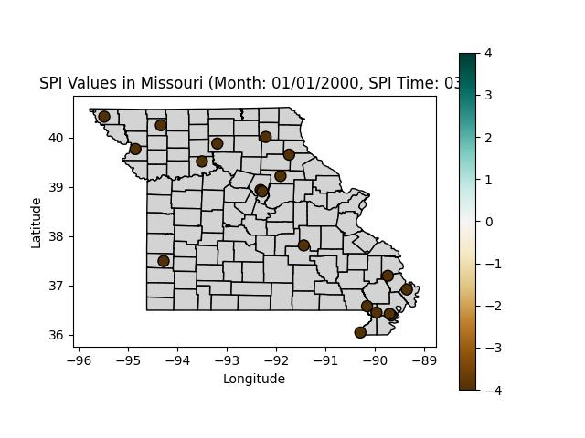

## Data Sources:

Data was almost exclusively obtained from Missouri Mesonet stations. One of the main objectives of this study is to show the utility of the Missouri Mesonet in serving the public. Other data sources were needed, however, in scenarios where data from a Mesonet station were missing for a short period, as the dataset's completeness is not a trivial matter. We determined that up to 8 months of data (<3% of data) missing was acceptable; if more than that was missing, the mesonet station in question was excluded from this analysis. Other sources included National Weather Service Cooperative Observer Program (NWS COOP) stations, located within 10 miles of the mesonet station in most cases (exceptions are explicitly stated in the Data Quality Control section), as well as the National Water Prediction Center's Precipitation Estimate (Multi-Sensor Data).

## Data Quality Control:

Data quality control was done through a mix of automated and manual steps. A Python program was written to inspect each Mesonet station’s data and output the following characteristics. The file name (Location), along with the first and last days of data, the highest and lowest precipitation values during this period, and any missing days in the file. These outputs were manually reviewed to ensure that the data matched expectations. Some adjustments were necessary to the data to ensure it met quality control standards.

First, the complete archive of Missouri Mesonet daily precipitation data from every currently operational and previously operational station was manually downloaded. Each of these files was a text file, which was then run through the quality control program mentioned above. With the output quality control statistics, it was time to decide which data would be used and which wouldn’t. A complete list of every station’s evaluation, with an assessment of its usability, the reasons for that, and where/when alternative data sources were used to fill in gaps, is found in **Appendix A**.

## Calculation of SPI (Standard Precipitation Index):

The Standardized Precipitation Index (SPI) is a widely used metric for quantifying precipitation deficits and surpluses, allowing for the assessment of drought conditions (McKee et al., 1993). To transform raw precipitation data into SPI values, we elected to use the National Drought Mitigation Center’s SPI Generator.

SPI is calculated by taking a large amount of data at constant time intervals and calculating how often at least a given value of precipitation falls on a given day. From there, explicit SPI values are calculated. Positive SPI values indicate wet conditions, while negative SPI values indicate dry conditions.

The U.S. Drought Monitor utilizes the SPI as a general indicator of drought severity. SPI can be interpreted as follows:

***This comes directly from*** [***https://droughtmonitor.unl.edu/About/AbouttheData/DroughtClassification.aspx***](https://droughtmonitor.unl.edu/About/AbouttheData/DroughtClassification.aspx)

| **Category** | **Description** | | **Example Percentile Range for Most Indicators** | | **Values for Standard Precipitation Index** | |
| --- | --- | --- | --- | --- | --- | --- |
| **None** | | Normal or wet conditions | | 30.01 or Above | | -0.49 or above |
| **D0** | | Abnormally Dry | | 20.01 to 30.00 | | -0.5 to -0.79 |
| **D1** | | Moderate Drought | | 10.01 to 20.00 | | -0.8 to -1.29 |
| **D2** | | Severe Drought | | 5.01 to 10.00 | | -1.3 to -1.59 |
| **D3** | | Extreme Drought | | 2.01 to 5.00 | | -1.6 to -1.99 |
| **D4** | | Exceptional Drought | | 0.00 to 2.00 | | -2.0 or less |

It should be noted that the Standard Precipitation Index is not the only data indicator used by the US Drought Monitor; however, it serves as a valuable starting point (National Drought Mitigation Center).

The National Drought Mitigation Center SPI generator program was used to calculate SPI values using the data previously mentioned above. It was reformatted using a Python program to ensure compatibility with the SPI generator. This program exported Excel files for use in data analysis. The exported data included SPI data for 1, 3, 6, and 12 months, as well as drought periods at thresholds of -1.0, -1.5, -2.0, -2.5, -3.0, -3.5, and -4.0 at the previously mentioned time scales. Drought frequency at different time scales was also output with various thresholds. The calculations from the SPI generator program and the resulting data were used to identify trends and to produce the visualizations presented later in the paper. These were also examined across three of the four time scales in the analysis: 3, 6, and 12 months. Below is the utility of the time scales:

The 3-month SPI indicates a seasonal drought by showing the rainfall data from the past season. This reflects short to medium-term trends in drought, and while not overly reactive to one-month variance, it is reactive enough to reflect seasonal changes in precipitation. However, in some areas, it may be too reactive to accurately reflect medium to long-term changes in drought at a given location (National Drought Mitigation Center).

That’s where 6-month SPI comes in. A 6-month SPI is ideal for monitoring medium-term trends and is particularly effective for observing the overall seasonal rainfall pattern of a given location, as it captures the conditions leading into a season, rather than just that season in isolation. For some, though, especially those who care about the long term, this timescale can still be a bit too reactive (National Drought Mitigation Center).

That’s why 12-month SPI exists. It accounts for the previous year’s precipitation and draws conclusions from that. So, while a 3-month SPI may react to one good month of precipitation, the 12-month SPI won’t be so reactive. Longer SPIs tend to be less extreme than their short-term counterparts. (National Drought Mitigation Center).

# Drought Data Analysis:

## Notes about Data Analysis:

The upcoming data analysis will be conducted using the SPI data collected. The variables listed below will be examined:

SPI Intensity: Threshold values of -0.5 and -1.3 were selected. These SPI values are the two most significant, as they represent the D0 (abnormally dry) and D2 (severe) drought thresholds, respectively (National Drought Mitigation Center). In other words, you can look at -0.5 as the threshold for low-impact drought (multiple times a year), and -1.3 as the threshold for high-impact (1 in 10-year or worse) drought. Using these two thresholds as our primary values for analysis, we also examined additional variables.

Average duration: Average amount of time an individual drought would last at a Mesonet station in months.

Frequency: How often a Mesonet station was in a drought during the 24-year period in %

Longest duration: Longest lasting drought at a Mesonet station in the 24-year period, in months

* These durations are the **most extreme values** currently observed. This means that their purpose is **not** to show what to expect, but to illustrate the **worst case** you might experience over a 24-year period.

Onset seasonality: The season most common for a Mesonet station to observe drought onset

Relief seasonality: The season most common for a Mesonet station to observe drought relief

### A Note About Seasonality:

Seasons for the purpose of this paper will be meteorological seasons. Three-month periods starting on the first day of the first month, and ending on the last day of the last month. The three-month periods that constitute the four seasons in meteorology are as follows (National Oceanic and Atmospheric Administration, 2024):

Spring: March, April, May

Summer: June, July, August

Autumn: September, October, November

Winter: December, January, February

**Winter is being *EXCLUDED* from drought-seasonality data:** Precipitation measurements at Missouri Mesonet stations are affected by the type of equipment used. These stations rely on tipping-bucket rain gauges, which are effective for measuring liquid precipitation but cannot accurately measure winter precipitation types. Snow, sleet, and freezing rain can accumulate and freeze within these gauges, leading to an underreporting of total precipitation during the winter months.

## Short-Term Drought: (3-month SPI)

### Low-Impact:

#### Average Duration:

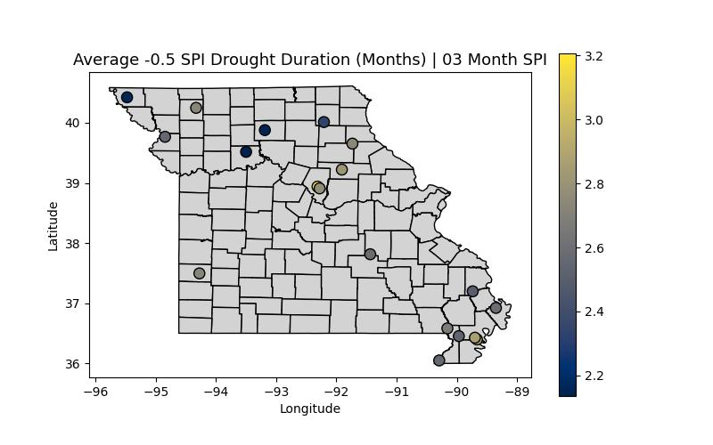

This map shows the average duration of short-term low-impact droughts in the state of Missouri over the past 24 years. Northern Missouri’s droughts appear to be a bit shorter than southern Missouri’s. Overall, though, these droughts last 2-3 months on average. Next, we will examine the frequency of short-term low-impact drought.

#### Frequency:

This map shows the frequency, in %, of short-term, low-impact droughts in the state of Missouri over the past 24 years. Eastern portions of the state tend to experience droughts more frequently than western portions. Overall, though, these droughts occur about 25-35% of the time in Missouri. Next, we will examine the longest-duration short-term low-impact drought.

This map shows the longest duration of short-term low-impact droughts in the state of Missouri over the past 24 years. The most extreme short-term drought durations appear to be in the 6-10 month range, although, notably, the Bootheel had a station that was in drought for over a year. The Bootheel has many interesting outliers throughout the years, and its characteristics are detailed in the microclimates section of this paper. Next, we will examine the onset seasonality of short-term low-impact drought.

#### Onset Seasonality:

This map illustrates the most frequent onset seasonality of short-term, low-impact droughts in the state of Missouri over the past 24 years. The northwestern portions of the state tend to experience springtime drought onset. The bootheel has a mix of the most frequent onset occurring between spring and fall. Regardless, transitional seasons seem to be when drought onset is most common statewide. Notably, a couple of stations in north-central Missouri show that the most common time for drought onset is in the summer. Next, we will examine the seasonal pattern of short-term, low-impact drought.

Reminder: Winter is excluded from seasonality analysis due to frozen precipitation

#### Relief Seasonality:

This map illustrates the most frequent relief seasonality of short-term, low-impact droughts in the state of Missouri over the past 24 years. Drought relief across the state typically peaks in the spring. Every station in the bootheel is either spring or spring tied with another season for the most common relief season. This makes sense, given that some of the state's wettest conditions occur in the spring. It is notable that a few stations, especially in north-eastern Missouri, favor fall for the most probable fall relief. A notable outlier remains Sanborn Field in Boone County, where the most frequent drought relief occurs in the summer. Next, we will examine the average duration of short-term high-impact drought.

Reminder: Winter is excluded from seasonality analysis due to frozen precipitation

### High-Impact:

#### Average Duration:

This map shows the average duration of short-term high-impact droughts in the state of Missouri over the past 24 years. The most notable extreme is the station near the Dent/Crawford county line, which shows notably longer high-impact drought duration than the other stations. Overall, though, these droughts last 1-2 months on average. Next, we will examine the frequency of short-term high-impact drought.

This map shows the frequency, in %, of short-term, high-impact droughts in the state of Missouri over the past 24 years. The central portions of Missouri experience drought least frequently, while the northwestern portions of the state experience high-impact drought considerably more often. Another notable feature is the Mississippi County station in the Bootheel, which has a longer drought duration than its surrounding stations. Overall, though, these droughts occur about 9-13% of the time in Missouri. Next, we will examine the longest-duration short-term high-impact drought.

This map shows the longest duration of short-term high-impact droughts in the state of Missouri over the past 24 years. The most extreme short-term drought durations appear to be in the 3-6 month range; notably, two stations had 6-month high-impact droughts: a Dunklin County station and a Crawford County station. Next, we will examine the onset seasonality of short-term high-impact drought.

#### Onset Seasonality:

This map illustrates the most frequent onset seasonality of short-term, high-impact droughts in the state of Missouri over the past 24 years. The dominant season for the onset of high-impact drought is Spring. Northwestern Missouri bucks the trend somewhat, with fall and summer being the most common onset seasons; beyond that, the remainder of the state, albeit with a couple of exceptions, sees spring as the most common onset season. Next, we will examine the relief seasonality of short-term high-impact drought.

Reminder: Winter is excluded from seasonality analysis due to frozen precipitation

#### Relief Seasonality:

This map illustrates the most frequent relief seasonality of short-term, high-impact droughts in the state of Missouri over the past 24 years. Drought relief for high-impact droughts varies by seasonality, depending on your location within the state. In northwestern and central Missouri, fall is the dominant season for relief; however, a couple of stations show summer to be most common. This makes sense, as one or two heavy summer-time storms can bring some relief, but these tend to be too small in scale to bring widespread relief. The bootheel has an abundant signal for Spring, being the most common season for drought relief. This may be due to warmer temperatures, which cause liquid rainfall to occur earlier in the year than in other parts of the state. This is especially important given the limitations of the rain gauges we have. Next, we will examine the average duration of medium-term low-impact drought.

Reminder: Winter is excluded from seasonality analysis due to frozen precipitation

## Medium-Term Drought: (6-month SPI)

### Low-Impact:

This map shows the average duration of medium-term low-impact droughts in the state of Missouri over the past 24 years. Droughts tend to last longer in southeastern Missouri compared to northwestern Missouri. Overall, these droughts last 3-5 months on average. Next, we will examine the frequency of medium-term low-impact drought.

#### Frequency:

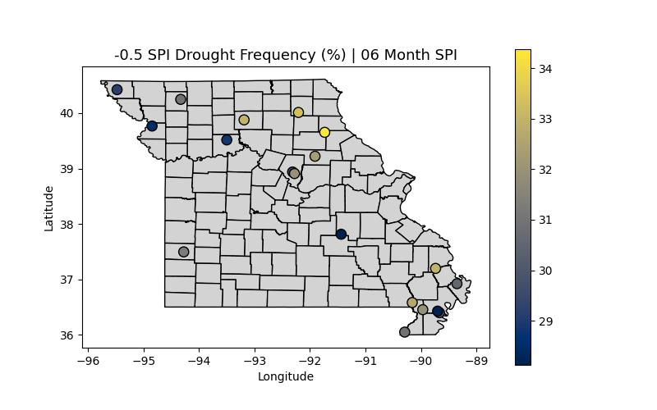

This map shows the frequency in % of medium-term low-impact droughts in the state of Missouri over the past 24 years. Drought occurs most often in northwestern Missouri. Overall, these droughts occur about 28-35% of the time in Missouri. Next, we will examine the longest-duration medium-term low-impact drought.

This map shows the longest duration of medium-term low-impact droughts in the state of Missouri over the past 24 years. Longest drought durations vary somewhat wildly across the state. Many stations' longest droughts last 10-16 months; however, a few are even more extreme. The Barton County station is the most extreme; it once endured a drought lasting 22 consecutive months! Next, we will examine the onset seasonality of medium-term low-impact drought.

#### Onset Seasonality:

This map illustrates the most frequent onset seasonality of medium-term, low-impact droughts in the state of Missouri over the past 24 years. The story of spring dominating drought onset continues. All but four stations in the state indicate that spring is the most common onset season. This is a pretty clear signal, likely due to spring being a volatile season. Next, we will examine the relief seasonality of medium-term low-impact drought.

Reminder: Winter is excluded from seasonality analysis due to frozen precipitation

#### Relief Seasonality:

This map illustrates the most frequent relief seasonality of medium-term, high-impact droughts in the state of Missouri over the past 24 years. Relief seasonality has an even stronger spring signal. Just three stations in the state go against this; however, unlike with onset, there is a regional component. Northwestern Missouri appears to be more prone to the onset of summer drought. Next, we will examine the average duration of medium-term high-impact drought.

Reminder: Winter is excluded from seasonality analysis due to frozen precipitation

### High-Impact:

This map shows the average duration of medium-term high-impact droughts in the state of Missouri over the past 24 years. Western Missouri has longer high-impact droughts than eastern Missouri. Southwestern Missouri appears to be the most extreme, with an average duration exceeding 3 months at one station. Overall, these droughts last an average of 2-3 months. Next, we will examine the frequency of medium-term high-impact drought.

This map shows the frequency, in %, of medium-term, high-impact droughts in the state of Missouri over the past 24 years. The bootheel has notably high frequencies, with Pemiscot County in high-impact drought 13% of the time. Overall, these droughts occur about 9-13% of the time in Missouri. Next, we will examine the longest-duration medium-term high-impact drought.

This map shows the longest duration of medium-term high-impact droughts in the state of Missouri over the past 24 years. Most stations' longest high-impact droughts were 5-9 months. Once again, however, Crawford County stands out with an extreme event. That station experienced a drought lasting 11 consecutive months. Next, we will examine the onset seasonality of medium-term high-impact drought.

#### Onset Seasonality:

This map illustrates the most frequent onset seasonality of medium-term, high-impact droughts in the state of Missouri over the past 24 years. Northeastern Missouri typically experiences drought relief in the summer. The remainder of the state typically sees relief most often in the Spring or fall. Next, we will examine the relief seasonality of medium-term high-impact drought.

Reminder: Winter is excluded from seasonality analysis due to frozen precipitation

#### Relief Seasonality:

This map illustrates the most frequent relief seasonality of medium-term, high-impact droughts in the state of Missouri over the past 24 years. Relief seasonality is most common in the Spring across the state. The South Farms Station in Boone County has the most common relief in the summer, which is fascinating. A few stations also have fall as the most common relief season. Next, we will examine the average duration of long-term low-impact drought.

Reminder: Winter is excluded from seasonality analysis due to frozen precipitation

## Long-Term Drought: (12-month SPI)

### Low-Impact:

This map shows the average duration of long-term low-impact droughts in the state of Missouri over the past 24 years. The immediate eye-catcher is the Barton County station, with an average drought duration nearing 11 months. Overall, these droughts last an average of 4-6 months. Next, we will examine the frequency of long-term low-impact drought.

This map shows the frequency, in %, of long-term low-impact droughts in the state of Missouri over the past 24 years. Northwestern and southeastern Missouri experience droughts more frequently, while central Missouri experiences them less often. Overall, these droughts occur about 20-35% of the time in Missouri. Next, we will examine the longest-duration long-term low-impact drought.

This map shows the longest duration of long-term low-impact droughts in the state of Missouri over the past 24 years. The bare minimum for the longest low-impact drought is a year. They can go longer, though, with the Gentry County station being in drought for over two years! Next, we will examine the onset seasonality of long-term low-impact drought.

#### Onset Seasonality:

This map illustrates the most frequent onset seasonality of long-term, low-impact droughts in the state of Missouri over the past 24 years. The signal here is less clear than in other drought severities and time scales, but there are still some conclusions to draw here. The primary conclusion is that the onset of the northern Missouri drought is most common in the summer. Beyond that, the spring and fall seem to be the most common for the remaining stations. Next, we will examine the seasonal variation in relief associated with long-term low-impact drought.

Reminder: Winter is excluded from seasonality analysis due to frozen precipitation

#### Relief Seasonality:

This map illustrates the most frequent relief seasonality of long-term, low-impact droughts in the state of Missouri over the past 24 years. Relief seasonality is most commonly spring. Central Missouri, in particular, has a strong spring signal. Southeastern Missouri is most commonly associated with Spring and Fall, while Western Missouri is associated with Spring and Summer. Next, we will examine the average duration of long-term high-impact drought.

Reminder: Winter is excluded from seasonality analysis due to frozen precipitation

### High-Impact:

This map shows the average duration of long-term high-impact droughts in the state of Missouri over the past 24 years. Barton County is once again the major outlier, with an average high-impact drought duration of over eight months. Overall, these droughts last an average of 2-5 months. Next, we will examine the frequency of long-term high-impact drought.

This map shows the frequency, in %, of long-term, high-impact droughts in the state of Missouri over the past 24 years. Knox County is an outlier, as it experiences high-impact droughts only 4% of the time, which is significantly less common there than in the rest of the state. Overall, these droughts occur about 9-12% of the time in Missouri. Next, we will examine the longest-duration long-term high-impact drought.

This map shows the longest duration of long-term high-impact droughts in the state of Missouri over the past 24 years. The key takeaway is that the longest high-impact drought in Missouri spans a wide range of durations. These range anywhere from 3 to 14 months. Overall, we notice a slight trend where the farther west you go, the longer the high-impact droughts last. Next, we will examine the onset seasonality of long-term high-impact drought.

#### Onset Seasonality:

This map illustrates the most frequent onset seasonality of long-term, high-impact droughts in the state of Missouri over the past 24 years. This varies by location, with some of the most robust spatial relationships observed in the paper. It is a resounding signal for Fall in the Missouri Bootheel, with spring being more probable in southwestern and central Missouri. The most common season for the onset of drought in Northern Missouri is the Summer. Next, we will examine the seasonal variation in relief associated with long-term high-impact drought.

Reminder: Winter is excluded from seasonality analysis due to frozen precipitation

#### Relief Seasonality:

This map illustrates the most frequent relief seasonality of long-term, high-impact droughts in the state of Missouri over the past 24 years. Drought relief has more mixed signals. In the Bootheel, drought relief is most common in the Spring and the Fall. In Northern Missouri, it is most common in the Fall, with no obvious season for drought relief in the rest of the state. Next, we will examine microclimate observations using Missouri Mesonet stations.

Reminder: Winter is excluded from seasonality analysis due to frozen precipitation

If you want a general overview with many of these stats for the Missouri Mesonet station closest to you for reference, you can find it in **Appendix C**.

## Microclimates:

Microclimates are exactly what they sound like: the climate of a small area/region (The Editors of Encyclopedia Britannica, 2025). In this section, we will investigate how Missouri mesonet stations, which are located close to each other, vary across different metrics. How similar are their rainfall totals? Do they correlate well? How big a difference can 5 miles really make?

### Boone County:

The most obvious case of two stations close to one another is the two in Boone County that were used in this analysis. The one at Sanborn Field, and the one at South Farm. These stations are approximately 3 miles apart, so it is intuitive to think that they will have very similar data.

#### 1 Month SPI Time Series:

The first way to evaluate this is to look at a time series. Examining the monthly data over the entire period of record, are Sanborn and South Farm comparable?

The answer is yes: these two stations are very similar; however, especially when it comes to extremes, there are brief periods during which they vary more substantially. The most notable difference between the two stations occurred in August 2007. Sanborn Field had an SPI of -0.74, while South Farm had an SPI of -1.95. That means Sanborn had a month that was abnormally dry (D0). While South Farm experienced a month that was extremely dry (D3). This variance all comes down to one day, August 24th, 2007. Sanborn Field picked up 1.97” of rain that day, while South Farm only picked up 0.53”. What a difference 3 miles makes!

#### Correlation:

Correlation is “a phenomenon that accompanies another phenomenon, is usually parallel to it, and is related in some way to it” (Merriam-Webster), or to put it in layman's terms, it is the similarity between two sets of data. Correlation can be measured through a correlation coefficient. Think of this as a “correlation score”. This score is measured from -1 to +1. If the correlation between two sets of data is +1, that means the data in both sets change in exactly the same way. If the correlation between two sets of data is -1, that means they change in exactly the opposite way. A correlation of 0 means that the two datasets have no relationship whatsoever. In this case, we are curious about how closely related the two sets of data are. What is the correlation coefficient between Sanborn Field and South Farms? This is a nuanced question; for the purposes of this paper, we will use the 03M SPI, as it is the most useful dataset for agricultural purposes.

The correlation between Sanborn Field and South Farms is ***0.97***. This is *incredibly* high, validating our intuition that these two stations are largely similar and, from a climatological perspective, are virtually the same. The time series shows that over a 24-year record, the extreme values tend to be “smoothed out”. However, if you examine smaller segments of the data, these two stations can exhibit significant variations.

#### Variance (Standard Deviation):

Variance tells us another piece of the puzzle. It is defined as “the fact, quality, or state of being variable or variant” (Merriam-Webster).  How consistent is the data at these stations? Are they all over the place, or are they steady? Variance, or in this case, standard deviation, can help us determine this. To measure the consistency of the climate at each Boone County station, we calculated the standard deviation of their annual precipitation. A lower number means the year-to-year rainfall totals are more predictable.

|  |  |
| --- | --- |
|  | Standard Deviation |
| Sanborn Field | 8.54” |
| South Farms | 8.04” |

Using a very rudimentary but useful analysis, the data shows South Farms has a slightly lower standard deviation (8.04") than Sanborn Field (8.54"), indicating a more consistent climate.

#### Correlation and Variance:

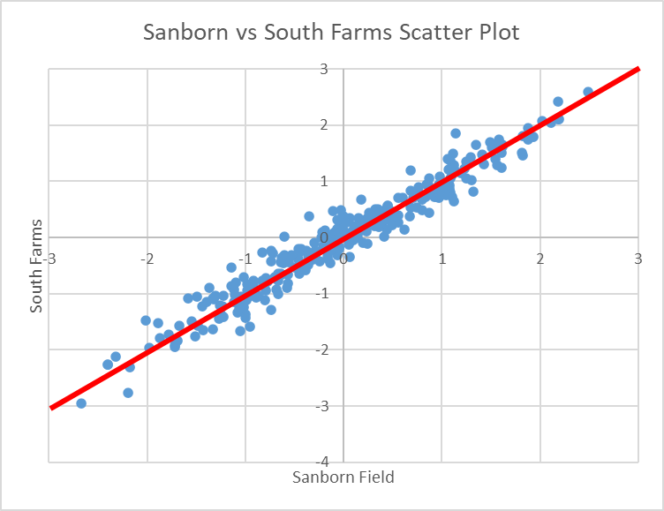

One of the best ways to visualize both correlation and variance is to use a scatter plot. A scatter plot is a graph that displays points to compare two values. In this case, the X-axis is Sanborn Field 3M SPI, and the Y-axis is the corresponding South Farms 3M SPI at the same time.

### Bootheel:

Another place that warrants further investigation from a micro-climate standpoint is the Missouri Bootheel. There are 7 stations with a full 24-year period of record on them that go down there! Let’s analyze the correlation and variance before combining them.

#### Correlation:

Correlation, as established, essentially measures the similarity between two sets of data, in this case, the drought data from two stations. Below is a “correlation matrix”, a fancy term for a bunch of boxes telling you how similar two stations are. For example, to see how similar Charleston and Portageville are, you can look at their respective rows and columns and find the value you’re looking for. Portageville and Hayward appear the most similar of the stations in the matrix, with a correlation of 0.95, which is almost as close as that of the Boone County stations. The least related of the stations appears to be the Charleston and Cardwell stations, with a correlation of 0.71. To be clear, 0.71 still means these stations are closely related, but they are the least closely related of the stations in the matrix.



#### Variance (Standard Deviation):

Just as with the Boone County stations, we measured the consistency of the Bootheel locations using the standard deviation of annual precipitation. The values ranged from a more consistent 7.57" at Clarkton to a more variable 8.64" at Glennonville. This 14% difference shows that even within the Bootheel, some areas have a more predictable climate than others.

|  |  |
| --- | --- |
|  | Standard Deviation |
| Clarkton | 7.57” |
| Charleston | 7.73” |
| Cardwell | 8.01” |
| Portageville | 8.61” |
| Hayward | 8.48” |
| Glennonville | 8.64” |
| Delta | 8.56” |

# Missouri Mesonet Drought Tracking:

Below is a step-by-step guide to tracking drought using the drought chart provided in **Appendix B.**

***Note: Website interface is current as of February 2026. Features and layout are subject to change.***

To begin, find out which Mesonet station in the study is closest to you. You’ll want to navigate to http://agebb.missouri.edu/weather/stations/, where you’ll find a map of the stations available. Once you find a station you are satisfied with, check any of the drought charts in Appendix B to ensure that the station is on the list. Assuming that is the case, you are ready to proceed to the next step.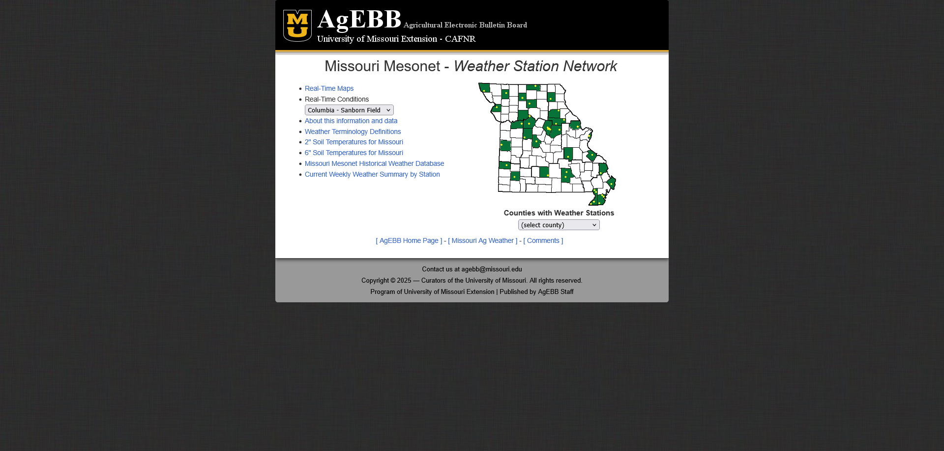

The next step is determining which season you would like to evaluate for drought. Most people will want the most recent season, but here are the months evaluated for the different seasons:

Spring: March, April, May

Summer: June, July, August

Autumn: September, October, November

Winter: December, January, February

Once your season is determined, pull up the associated drought chart. Now comes the fun part: getting the data.

To begin, on the page you first navigated to when finding your station, click the “Missouri Mesonet Historical Weather Database.”

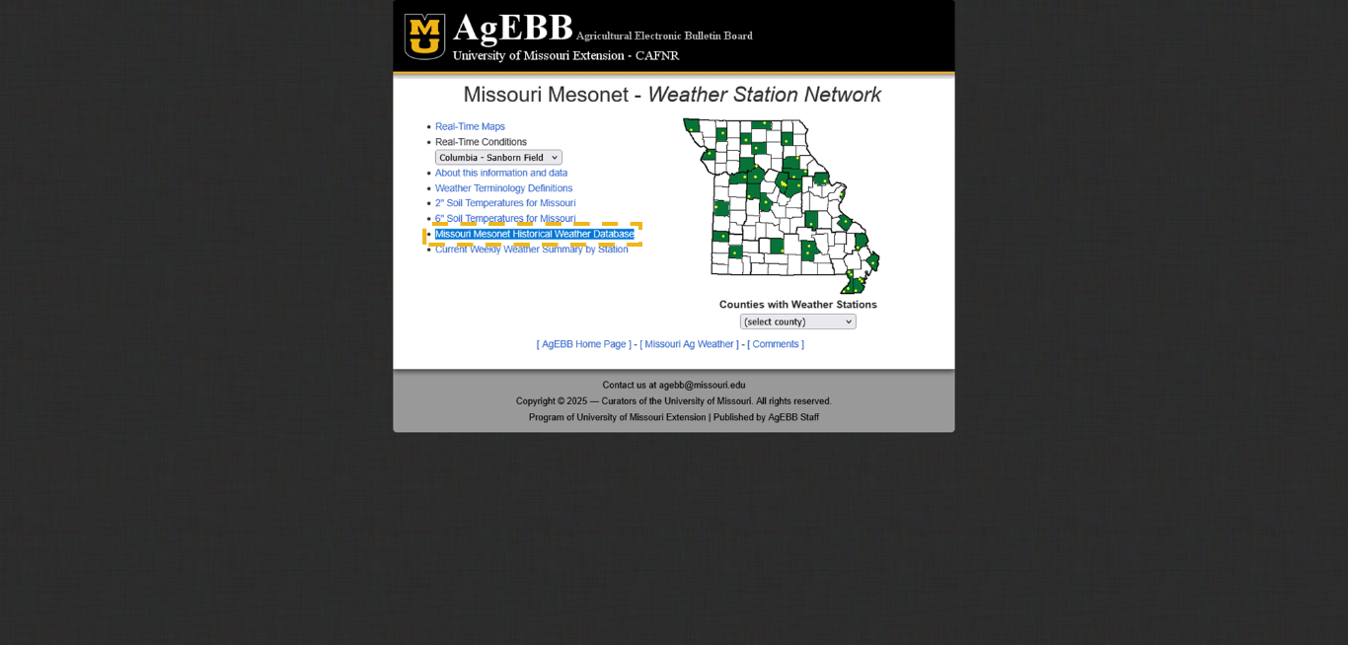

You should then find yourself on the following web page:

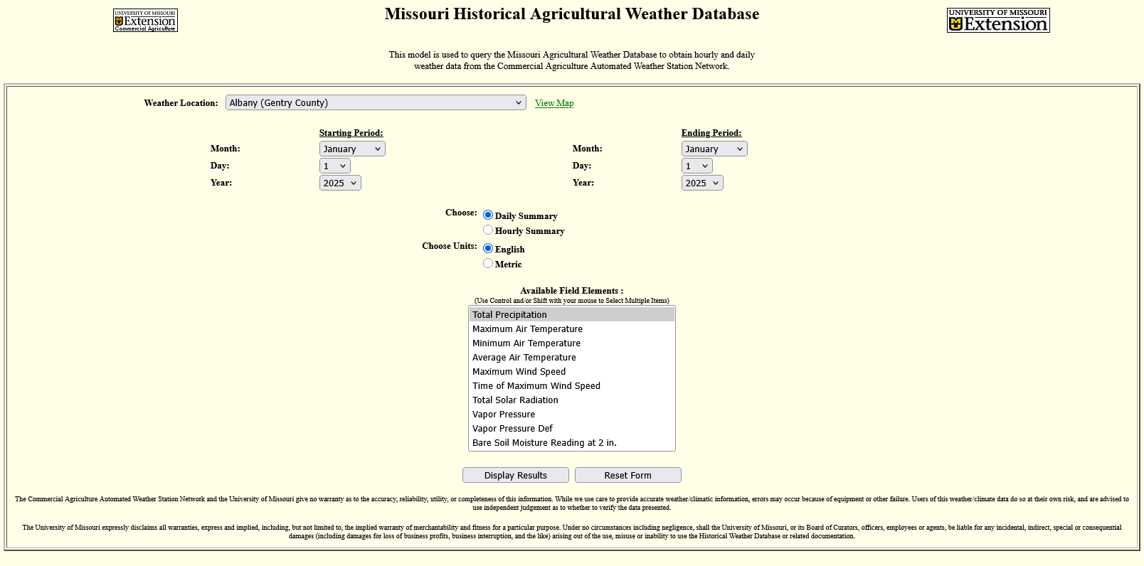

From here, there are two ways you can select the station you’re looking for. The first is to click on the dropdown menu next to the text “Weather Location:”, and then select the station you want.

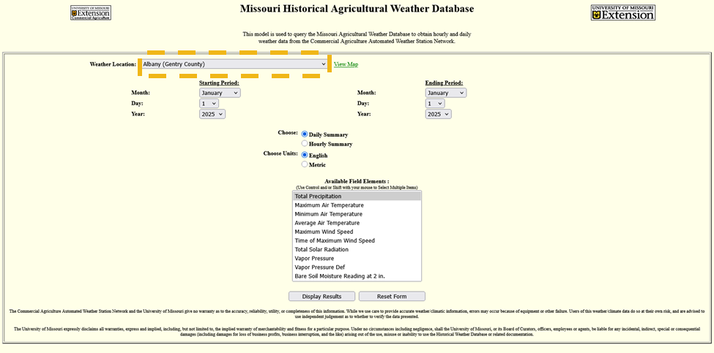

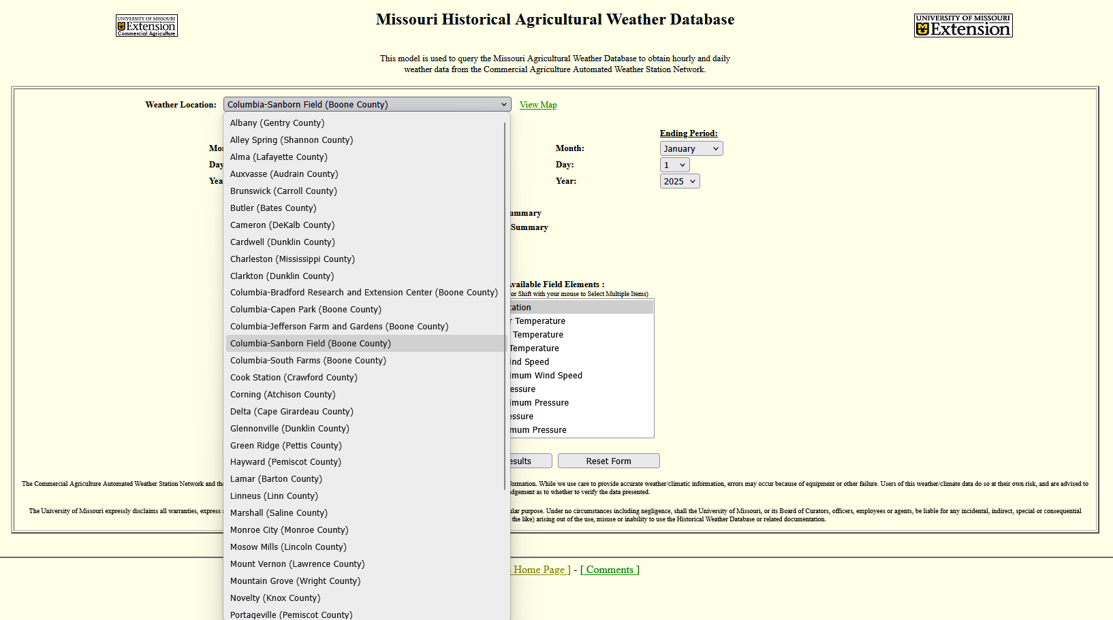

The other way to select a station is to click the “view map” button next to the dropdown menu, then click the location you want. The map will look like this:

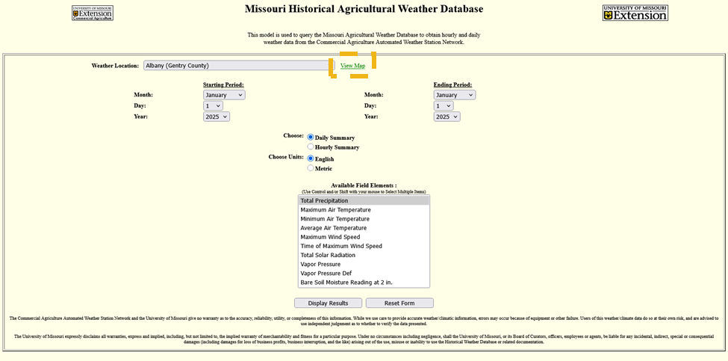

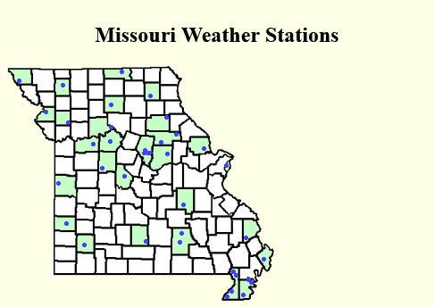

For this example, I will use the location “Columbia-Sanborn Field (Boone County)”

Our attention then shifts to the period we are interested in. In this case, we will want our period to be from the first day of the first month of a season to the last day of the last month of a season. Use the dropdown menus for the start and end periods to select what you want. In this case, I will evaluate the Spring 2025 drought, so I will select the period from March 1, 2025, to May 31, 2025.

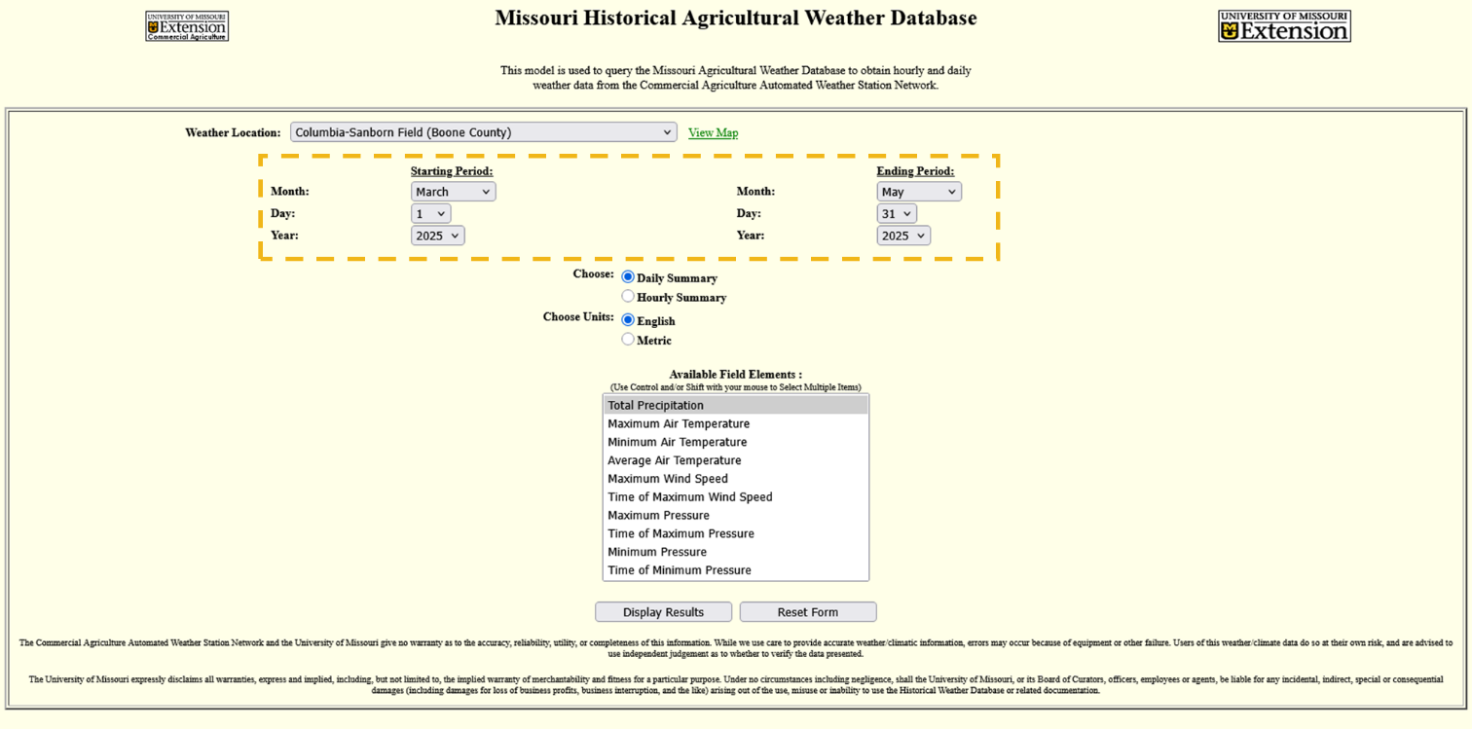

After that, we want to make sure our data is formatted correctly. We want to leave the Choose and Choose Units options untouched; they are our default settings.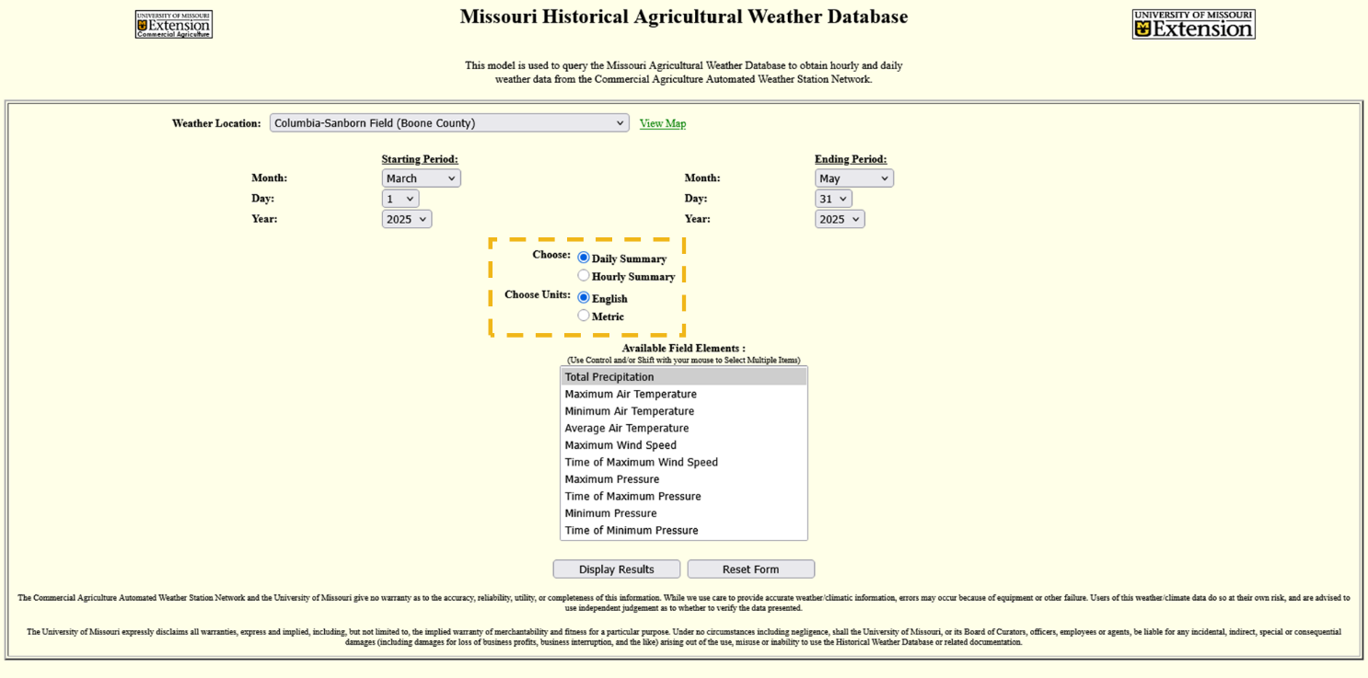

Finally, and conveniently for us, we need to select the variables we are interested in; in this case, “Total Precipitation” is what we want, and it is already selected.

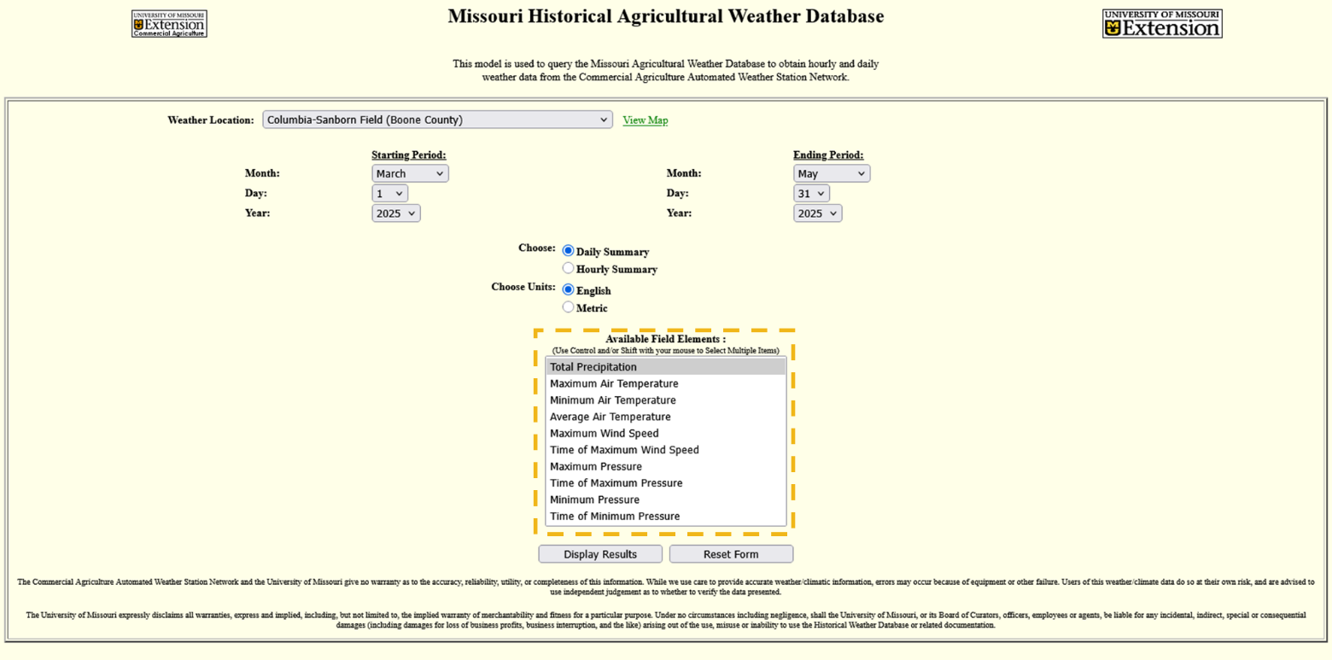

Now, click the “Display Results” button.

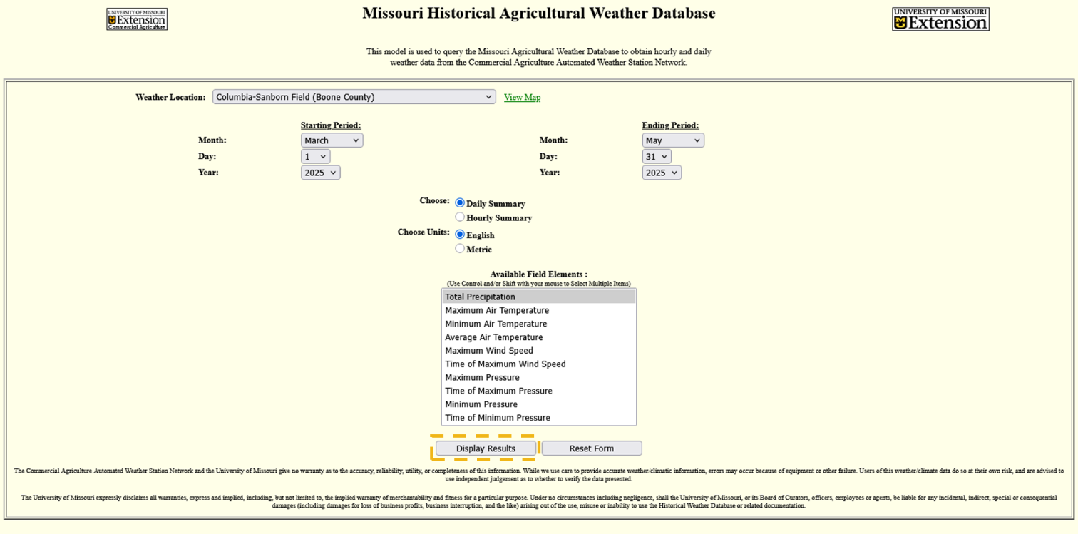

You will be presented with a long list of data, showing the total precipitation in inches for each day we requested. The good news is that we don’t need to go through every single day and add everything together; we just need to scroll to the bottom of the page and get the “Total:” value.

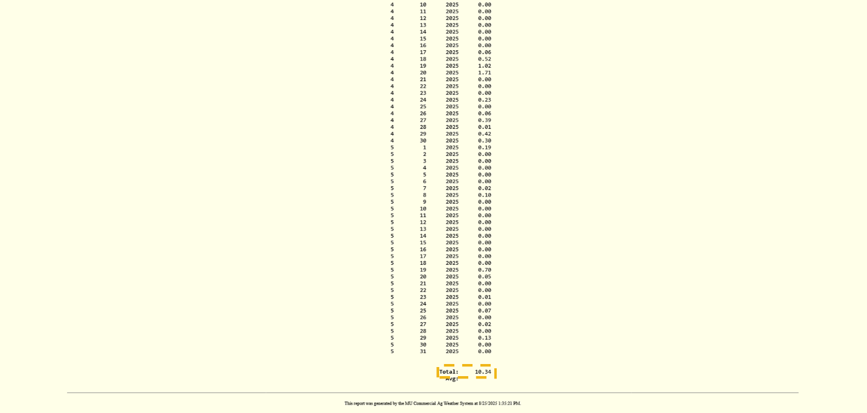

Now for the part we’ve been waiting for, let’s bring out the drought chart. In this example, I will use the Spring one, but they are all used the same way. You can find them in **Appendix B**.

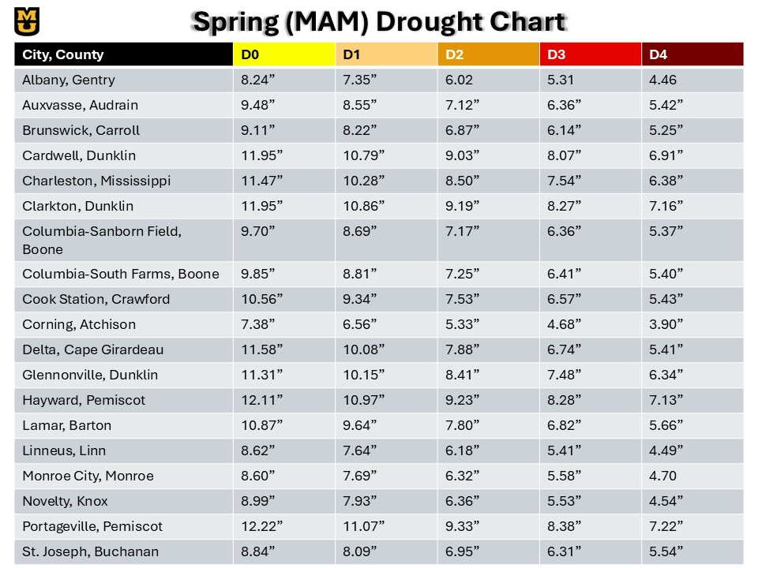

The drought chart lists the stations in the first column, followed by the corresponding precipitation values for D0-D4 drought. The rule of thumb is that we will work from D0 to D4 and see if our precipitation value is ***less than OR equal to*** the value needed for the drought category we are assessing.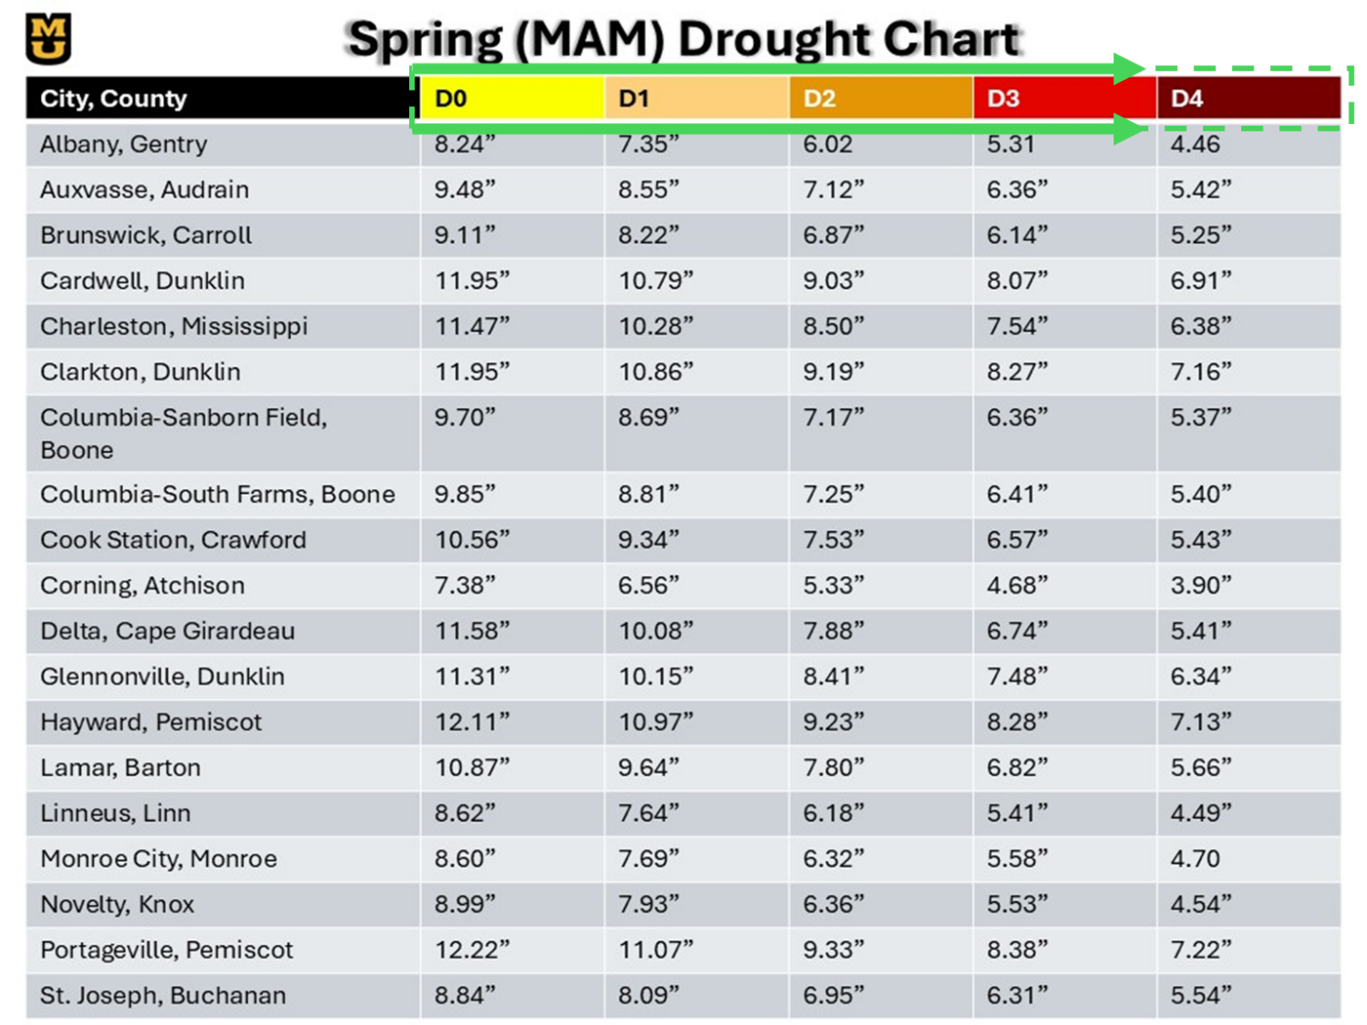

At Sanborn Field for the Spring of 2025. Our value is 10.34”, and D0 is 9.70”, therefore, using this method, we were not in a drought this spring. Let’s say the value was hypothetically, 5.41”, how would that work? We would work our way inwards. 5.41” is less than 9.70”, so we are in at least D0. What about D1? D1 is 8.69”, which is higher than 5.41”, so we are in at least D1. D2 is 7.17”, and D3 is 6.36”, so we are in at least D3. D4 is 5.37”, while 5.41” is close, it is **greater than** the D4 threshold, and therefore we are **NOT** in D4.

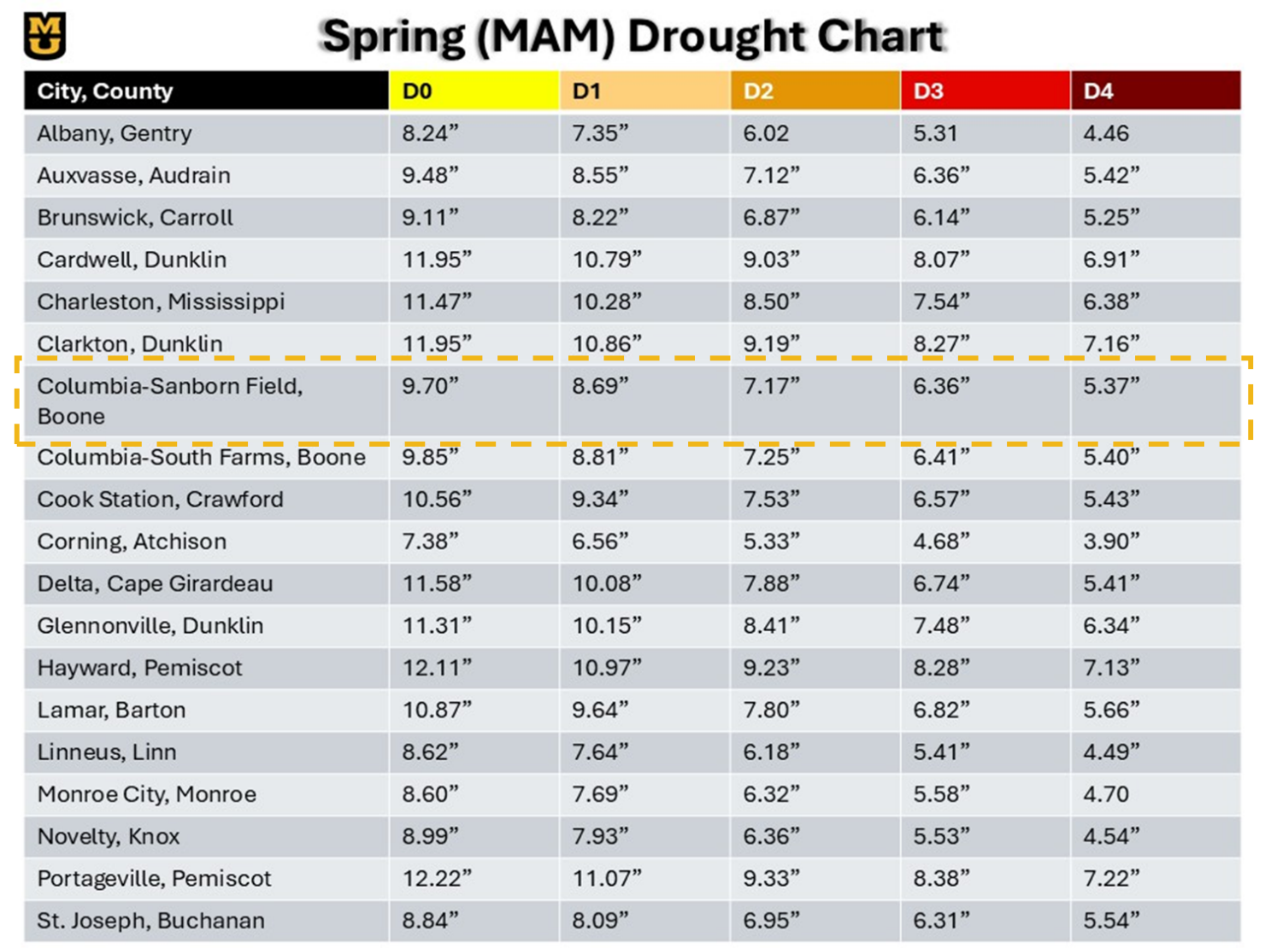

# Conclusions:

## Key Findings:

Droughts occur frequently in Missouri, with low-impact droughts happening as much as 35% of the time in some locations, and high-impact droughts taking place over 10% of the time in others. We have also observed that drought duration, frequency, and intensity vary across the state. Short-term low-impact droughts generally last 2-3 months, while long-term droughts can extend for 6 months or more. High-impact droughts usually last 3 months or less; however, in extreme circumstances, they can persist for nearly a year. Seasonality plays a role, but the Mesonet is significantly limited in assessing seasonality because it cannot account for freezing rain, sleet, or snow. Still, evidence suggests that high-impact droughts are most likely to occur in the spring and often end due to an extreme rainfall event. There are notable differences between microclimates, with stations in close proximity sometimes showing variation in drought conditions. The Missouri Mesonet greatly enhances drought monitoring where it is available. Finally, the 24-year record period used in this study, while not short, is less than the standard 30-year period recommended for climatology reports. This means that extreme events might have a greater influence on our data than usual.

## Implications for Policy Makers and Stakeholders:

An improved understanding of drought patterns supports disaster preparedness, water resource management, and effective agricultural management. High-resolution weather station data and climate data must be supported and maintained to improve drought prediction and warning capability. Given the differences in drought frequency and location observed at stations in close proximity, it is crucial to emphasize that localized planning and resource allocation are necessary. A statewide plan isn’t good enough; needs vary drastically by location. Future investment in the Missouri Mesonet is necessary for accurate and timely drought assessment and response.

## For Future Research:

Future research can take a few directions:

The first is using Missouri Mesonet data to evaluate the accuracy of radar-estimated rainfall at various points in Missouri.

We can also use this drought climatology to determine whether incorporating it into S2S models enhances skillful predictability.

Finally, additional research on microclimates can be conducted using stations in close proximity to one another.

# Appendix A:

***Albany, Gentry County, MO***

Good for use: **Yes**

Changes: **None**

***Alley Spring, Shannon County, MO***

Good for use: **No**

Reasons: **The dataset only spans from 2005-2016, and months of data within that period are missing**

***Alma, Lafayette County, MO***

Good for use: **No**

Reasons: **The dataset began in 2019**

***Auxvasse, Audrain County, MO***

Good for use: **Yes**

Changes: **None**

***Brunswick, Carroll County, MO***

Good for use: **Yes**

Reasons: **Data spans from 2000 to 2024, however, a month and a half of data is missing from 2019, spanning from 05/26/2019 to 07/04/2019**

**Reconstructed Data:**

**Station Used: Keytesville, MO (GHCN, CoCoRAHS, MOFSA) (US1MOFSA041, MOFSA041, MOFSA041) (10.4 Miles Away), National Water Prediction Center Precipitation Estimate (Multi-Sensor Data)**

Month Day Year Precip(inches)

|  |  |  |  |
| --- | --- | --- | --- |
| **5        26      2019      0.08**  **5        27      2019      0.00**  **5        28      2019      0.06**  **5        29      2019      0.42**  **5        30      2019      0.03**  **5        31      2019      0.01**  **6         1      2019      0.00**  **6         2      2019      0.00**  **6         3      2019      0.00**  **6         4      2019      0.00** | **6         5      2019      0.00**  **6         6      2019      0.73**  **6         7      2019      0.00**  **6         8      2019      0.00**  **6         9      2019      0.00**  **6        10      2019      0.00**  **6        11      2019      0.00**  **6        12      2019      0.00**  **6        13      2019      0.49**  **6        14      2019      0.00** | **6        15      2019      0.85**  **6        16      2019      0.11**  **6        17      2019      0.25**  **6        18      2019      0.00**  **6        19      2019      0.28**  **6        20      2019      0.00**  **6        21      2019      0.00**  **6        22      2019      2.11**  **6        23      2019      1.88**  **6        24      2019      0.19** | **6        25      2019      0.00**  **6        26      2019      0.00**  **6        27      2019      0.00**  **6        28      2019      0.00**  **6        29      2019      0.00**  **6        30      2019      0.00**  **7         1      2019      0.00**  **7         2      2019      0.00**  **7         3      2019      0.00**  **7         4      2019      0.00** |

***Butler, Bates County, MO***

Good for use: **No**

Reasons: **The dataset began in 2015**

***Cameron, DeKalb County, MO***

Good for use: **No**

Reasons: **The dataset ended in 2004**

***Cardwell, Dunklin County, MO***

Good for use: **Yes**

Changes: **None**

***Charleston, Mississippi County, MO***

Good for use: **Yes**

Changes: **None**

***Clarkton, Dunklin County, MO***

Good for use: **Yes**

Reasons: **While data began in 2000, it was August of 2000, so there was a lot of data that needed reconstruction.**

**Reconstructed Data:**

**Stations Used: Malden, MO (GHCN, COOP, NWSLI) (USC00235207, 235207, MLDM7) (7.3 Miles Away), Saint Francis, AR (GHCN, COOP, NWSLI) (USC00036380, 036380, SFRA4) (9.9 Miles Away)**

Month Day Year Precip(inches)

|  |  |  |  |
| --- | --- | --- | --- |
| **1         1      2000      0.00**  **1         2      2000      0.00**  **1         3      2000      4.26**  **1         4      2000      2.00**  **1         5      2000      0.01**  **1         6      2000      0.01**  **1         7      2000      0.00**  **1         8      2000      0.00**  **1         9      2000      0.00**  **1        10      2000      0.00**  **1        11      2000      0.00**  **1        12      2000      0.00**  **1        13      2000      0.01**  **1        14      2000      0.00**  **1        15      2000      0.00**  **1        16      2000      0.00**  **1        17      2000      0.00**  **1        18      2000      0.01**  **1        19      2000      0.00**  **1        20      2000      0.00**  **1        21      2000      0.00**  **1        22      2000      0.00**  **1        23      2000      0.10**  **1        24      2000      0.30**  **1        25      2000      0.00**  **1        26      2000      0.00**  **1        27      2000      0.00**  **1        28      2000      0.00**  **1        29      2000      1.40**  **1        30      2000      0.00**  **1        31      2000      0.00**  **2         1      2000      0.00**  **2         2      2000      0.00**  **2         3      2000      0.00**  **2         4      2000      0.00**  **2         5      2000      0.00**  **2         6      2000      0.00**  **2         7      2000      0.00**  **2         8      2000      0.00**  **2         9      2000      0.00**  **2        10      2000      0.00**  **2        11      2000      0.00**  **2        12      2000      0.32**  **2        13      2000      0.08**  **2        14      2000      0.05**  **2        15      2000      0.00**  **2        16      2000      0.00**  **2        17      2000      0.15**  **2        18      2000      2.20**  **2        19      2000      0.18**  **2        20      2000      0.00**  **2        21      2000      0.00**  **2        22      2000      0.00**  **2        23      2000      0.00** | **2        24      2000      0.30**  **2        25      2000      0.00**  **2        26      2000      0.11**  **2        27      2000      0.75**  **2        28      2000      0.00**  **2        29      2000      0.00**  **3         1      2000      0.00**  **3         2      2000      0.00**  **3         3      2000      0.17**  **3         4      2000      0.24**  **3         5      2000      0.00**  **3         6      2000      0.00**  **3         7      2000      0.00**  **3         8      2000      0.00**  **3         9      2000      0.00**  **3        10      2000      0.00**  **3        11      2000      0.08**  **3        12      2000      0.00**  **3        13      2000      0.00**  **3        14      2000      0.00**  **3        15      2000      0.00**  **3        16      2000      1.52**  **3        17      2000      0.08**  **3        18      2000      0.04**  **3        19      2000      0.46**  **3        20      2000      0.50**  **3        21      2000      0.02**  **3        22      2000      0.00**  **3        23      2000      0.00**  **3        24      2000      0.00**  **3        25      2000      0.00**  **3        26      2000      0.01**  **3        27      2000      0.05**  **3        28      2000      0.00**  **3        29      2000      0.01**  **3        30      2000      0.66**  **3        31      2000      3.84**  **4         1      2000      0.00**  **4         2      2000      0.11**  **4         3      2000      0.02**  **4         4      2000      0.00**  **4         5      2000      0.00**  **4         6      2000      0.00**  **4         7      2000      0.00**  **4         8      2000      0.14**  **4         9      2000      0.00**  **4        10      2000      0.00**  **4        11      2000      0.15**  **4        12      2000      0.20**  **4        13      2000      0.00**  **4        14      2000      0.00**  **4        15      2000      0.00**  **4        16      2000      0.00**  **4        17      2000      0.21** | **4        18      2000      0.00**  **4        19      2000      0.00**  **4        20      2000      0.00**  **4        21      2000      0.00**  **4        22      2000      0.00**  **4        23      2000      0.00**  **4        24      2000      0.22**  **4        25      2000      0.48**  **4        26      2000      0.00**  **4        27      2000      0.00**  **4        28      2000      0.00**  **4        29      2000      0.00**  **4        30      2000      0.00**  **5         1      2000      0.00**  **5         2      2000      0.00**  **5         3      2000      0.73**  **5         4      2000      0.08**  **5         5      2000      0.07**  **5         6      2000      0.20**  **5         7      2000      0.03**  **5         8      2000      0.00**  **5         9      2000      0.00**  **5        10      2000      1.12**  **5        11      2000      0.00**  **5        12      2000      0.00**  **5        13      2000      0.01**  **5        14      2000      0.00**  **5        15      2000      0.00**  **5        16      2000      0.00**  **5        17      2000      0.00**  **5        18      2000      0.00**  **5        19      2000      0.81**  **5        20      2000      0.00**  **5        21      2000      0.00**  **5        22      2000      0.00**  **5        23      2000      0.03**  **5        24      2000      0.00**  **5        25      2000      2.02**  **5        26      2000      0.36**  **5        27      2000      2.12**  **5        28      2000      1.10**  **5        29      2000      0.00**  **5        30      2000      0.00**  **5        31      2000      0.00**  **6         1      2000      0.00**  **6         2      2000      0.00**  **6         3      2000      0.00**  **6         4      2000      0.00**  **6         5      2000      0.00**  **6         6      2000      0.00**  **6         7      2000      0.00**  **6         8      2000      0.00**  **6         9      2000      0.00**  **6        10      2000      0.00** | **6        11      2000      0.01**  **6        12      2000      0.00**  **6        13      2000      0.00**  **6        14      2000      0.00**  **6        15      2000      0.38**  **6        16      2000      0.00**  **6        17      2000      0.00**  **6        18      2000      0.37**  **6        19      2000      0.57**  **6        20      2000      0.55**  **6        21      2000      0.57**  **6        22      2000      0.09**  **6        23      2000      0.00**  **6        24      2000      0.00**  **6        25      2000      0.00**  **6        26      2000      0.02**  **6        27      2000      0.65**  **6        28      2000      0.00**  **6        29      2000      0.08**  **6        30      2000      0.00**  **7         1      2000      0.01**  **7         2      2000      0.00**  **7         3      2000      0.00**  **7         4      2000      0.06**  **7         5      2000      0.00**  **7         6      2000      0.00**  **7         7      2000      0.00**  **7         8      2000      0.00**  **7         9      2000      0.00**  **7        10      2000      0.00**  **7        11      2000      0.00**  **7        12      2000      0.00**  **7        13      2000      0.00**  **7        14      2000      0.00**  **7        15      2000      0.00**  **7        16      2000      0.01**  **7        17      2000      0.00**  **7        18      2000      0.00**  **7        19      2000      0.12**  **7        20      2000      0.00**  **7        21      2000      0.30**  **7        22      2000      0.00**  **7        23      2000      0.01**  **7        24      2000      0.00**  **7        25      2000      0.00**  **7        26      2000      0.00**  **7        27      2000      0.00**  **7        28      2000      0.00**  **7        29      2000      0.27**  **7        30      2000      0.91**  **7        31      2000      0.00** |

***Columbia-Bradford Research and Extension Center, Boone County, MO***

Good for use: **No**

Reasons: **The dataset began in 2009**

***Columbia-Capen Park, Boone County, MO***

Good for use: **No**

Reasons: **The dataset began in 2011**

***Columbia-Jefferson Farm and Gardens, Boone County, MO***

Good for use: **No**

Reasons: **The dataset began in 2008**

***Columbia-Sanborn Field, Boone County, MO***

Good for use: **Yes**

Changes: **None**

***Columbia-South Farms, Boone County, MO***

Good for use: **Yes**

Changes: **None**

***Cook Station, Crawford County, MO***

Good for use: **Yes**

Changes: **None**

***Corning, Atchison County, MO***

Good for use: **Yes**

Reasons: **Data spans from 2000 to 2024, however, data is missing from 2012, spanning from 07/26/2012 to 08/05/2012, so reconstruction was needed**

**Reconstructed Data:**

**Stations Used: Fairfax, MO (COOP, NWSLI) (232731, FFXM7) (7.1 Miles Away), Falls City, NE (Barada, NE) (GHCN, CoCoRaHS) (US10rich006, 0rich006) (6.8 Miles Away)**

Month Day Year Precip(inches)

|  |  |  |  |
| --- | --- | --- | --- |
| **7        26      2012      1.36**  **7        27      2012      0.05**  **7        28      2012      0.00** | **7        29      2012      0.00**  **7        30      2012      0.00**  **7        31      2012      0.01** | **8         1      2012      0.00**  **8         2      2012      0.05**  **8         3      2012      0.05** | **8         4      2012      0.25**  **8         5      2012      0.26** |

***Delta, Cape Girardeau County, MO***

Good for use: **Yes**

Changes: **None**

***Glennonville, Dunklin County, MO***

Good for use: **Yes**

Changes: **None**

***Green Ridge, Pettis County, MO***

Good for use: **No**

Reasons: **The dataset began in 2004**

***Hayward, Pemiscot County, MO***

Good for use: **Yes**

Reasons: **The dataset began on May 31st, 2000, so reconstruction was needed**

**Reconstructed Data:**

**Stations Used: Portageville, MO (MO Mesonet) (mo6804) (2.9 Miles Away)**

Month Day Year Precip(inches)

|  |  |  |  |
| --- | --- | --- | --- |
| **1         1      2000      0.00**  **1         2      2000      2.35**  **1         3      2000      1.60**  **1         4      2000      0.02**  **1         5      2000      0.00**  **1         6      2000      0.00**  **1         7      2000      0.00**  **1         8      2000      0.00**  **1         9      2000      0.00**  **1        10      2000      0.00**  **1        11      2000      0.00**  **1        12      2000      0.22**  **1        13      2000      0.00**  **1        14      2000      0.00**  **1        15      2000      0.00**  **1        16      2000      0.00**  **1        17      2000      0.08**  **1        18      2000      0.00**  **1        19      2000      0.00**  **1        20      2000      0.00**  **1        21      2000      0.00**  **1        22      2000      0.30**  **1        23      2000      0.00**  **1        24      2000      0.00**  **1        25      2000      0.00**  **1        26      2000      0.00**  **1        27      2000      0.00**  **1        28      2000      0.00**  **1        29      2000      0.21**  **1        30      2000      0.00**  **1        31      2000      0.00**  **2         1      2000      0.00**  **2         2      2000      0.00**  **2         3      2000      0.00**  **2         4      2000      0.00**  **2         5      2000      0.00**  **2         6      2000      0.00**  **2         7      2000      0.00** | **2         8      2000      0.00**  **2         9      2000      0.00**  **2        10      2000      0.00**  **2        11      2000      0.17**  **2        12      2000      0.04**  **2        13      2000      0.42**  **2        14      2000      0.00**  **2        15      2000      0.00**  **2        16      2000      0.00**  **2        17      2000      1.70**  **2        18      2000      0.66**  **2        19      2000      0.00**  **2        20      2000      0.00**  **2        21      2000      0.00**  **2        22      2000      0.00**  **2        23      2000      0.45**  **2        24      2000      0.06**  **2        25      2000      0.00**  **2        26      2000      1.56**  **2        27      2000      0.00**  **2        28      2000      0.00**  **2        29      2000      0.00**  **3         1      2000      0.00**  **3         2      2000      0.00**  **3         3      2000      0.43**  **3         4      2000      0.00**  **3         5      2000      0.00**  **3         6      2000      0.00**  **3         7      2000      0.00**  **3         8      2000      0.00**  **3         9      2000      0.00**  **3        10      2000      0.00**  **3        11      2000      0.08**  **3        12      2000      0.00**  **3        13      2000      0.00**  **3        14      2000      0.00**  **3        15      2000      0.28**  **3        16      2000      1.91** | **3        17      2000      0.00**  **3        18      2000      0.39**  **3        19      2000      1.29**  **3        20      2000      0.02**  **3        21      2000      0.00**  **3        22      2000      0.00**  **3        23      2000      0.00**  **3        24      2000      0.00**  **3        25      2000      0.00**  **3        26      2000      0.02**  **3        27      2000      0.04**  **3        28      2000      0.00**  **3        29      2000      0.39**  **3        30      2000      0.00**  **3        31      2000      0.00**  **4         1      2000      0.07**  **4         2      2000      0.06**  **4         3      2000      0.01**  **4         4      2000      0.00**  **4         5      2000      0.00**  **4         6      2000      0.00**  **4         7      2000      0.02**  **4         8      2000      0.00**  **4         9      2000      0.00**  **4        10      2000      0.00**  **4        11      2000      0.92**  **4        12      2000      0.00**  **4        13      2000      0.00**  **4        14      2000      0.00**  **4        15      2000      0.00**  **4        16      2000      1.80**  **4        17      2000      0.00**  **4        18      2000      0.00**  **4        19      2000      0.00**  **4        20      2000      0.00**  **4        21      2000      0.00**  **4        22      2000      0.00**  **4        23      2000      0.23** | **4        24      2000      0.59**  **4        25      2000      0.00**  **4        26      2000      0.00**  **4        27      2000      0.00**  **4        28      2000      0.00**  **4        29      2000      0.00**  **4        30      2000      0.00**  **5         1      2000      0.00**  **5         2      2000      0.09**  **5         3      2000      0.14**  **5         4      2000      0.16**  **5         5      2000      0.00**  **5         6      2000      0.00**  **5         7      2000      0.00**  **5         8      2000      0.00**  **5         9      2000      0.71**  **5        10      2000      0.00**  **5        11      2000      0.00**  **5        12      2000      0.03**  **5        13      2000      0.24**  **5        14      2000      0.00**  **5        15      2000      0.00**  **5        16      2000      0.00**  **5        17      2000      0.01**  **5        18      2000      0.46**  **5        19      2000      0.00**  **5        20      2000      0.04**  **5        21      2000      0.00**  **5        22      2000      0.00**  **5        23      2000      0.02**  **5        24      2000      0.47**  **5        25      2000      0.18**  **5        26      2000      1.21**  **5        27      2000      3.62**  **5        28      2000      0.00**  **5        29      2000      0.00**  **5        30      2000      0.00** |

***Lamar, Barton County, MO***

Good for use: **Yes**

Changes: **None**

***Linneus, Linn County, MO***

Good for use: **Yes**

Changes: **None**

***Marshall, Saline County, MO***

Good for use: **No**

Reasons: **The dataset began in 2017**

***Monroe City, Monroe County, MO***

Good for use: **Yes**

Reasons: **The dataset began on May 31st, 2000, so reconstruction was needed**

**Reconstructed Data:**

**Stations Used: Clarence Cannon Dam, MO (GHCN, COOP, NWSLI) (USC00231600, 231600, CDAM7) (9.7 Miles Away), Palmyra, MO (COOP) (USC00236493) (15.1 Miles Away) (despite being over 10 miles away from the Monroe City Station, data was similar to the Clarence Cannon Dam station, which was within 10 miles of the Monroe City Station. Therefore, given no better sources, this data was used)**

Month Day Year Precip(inches)

|  |  |  |  |
| --- | --- | --- | --- |
| **1         1      2000      0.00**  **1         2      2000      0.00**  **1         3      2000      0.00**  **1         4      2000      0.20**  **1         5      2000      0.00**  **1         6      2000      0.00**  **1         7      2000      0.00**  **1         8      2000      0.00**  **1         9      2000      0.00**  **1        10      2000      0.19**  **1        11      2000      0.00**  **1        12      2000      0.00**  **1        13      2000      0.00**  **1        14      2000      0.00**  **1        15      2000      0.00**  **1        16      2000      0.00**  **1        17      2000      0.00**  **1        18      2000      0.05**  **1        19      2000      0.00**  **1        20      2000      0.00**  **1        21      2000      0.00**  **1        22      2000      0.00**  **1        23      2000      0.00**  **1        24      2000      0.00**  **1        25      2000      0.00**  **1        26      2000      0.00**  **1        27      2000      0.00**  **1        28      2000      0.00**  **1        29      2000      0.19**  **1        30      2000      0.00**  **1        31      2000      0.00**  **2         1      2000      0.00**  **2         2      2000      0.00**  **2         3      2000      0.00**  **2         4      2000      0.00**  **2         5      2000      0.00**  **2         6      2000      0.00**  **2         7      2000      0.00** | **2         8      2000      0.00**  **2         9      2000      0.00**  **2        10      2000      0.00**  **2        11      2000      0.00**  **2        12      2000      0.00**  **2        13      2000      0.00**  **2        14      2000      0.10**  **2        15      2000      0.00**  **2        16      2000      0.00**  **2        17      2000      0.00**  **2        18      2000      1.33**  **2        19      2000      0.00**  **2        20      2000      0.00**  **2        21      2000      0.00**  **2        22      2000      0.00**  **2        23      2000      0.00**  **2        24      2000      0.25**  **2        25      2000      0.00**  **2        26      2000      0.72**  **2        27      2000      0.00**  **2        28      2000      0.90**  **2        29      2000      0.00**  **3         1      2000      0.50**  **3         2      2000      0.00**  **3         3      2000      0.20**  **3         4      2000      0.27**  **3         5      2000      0.00**  **3         6      2000      0.00**  **3         7      2000      0.00**  **3         8      2000      0.00**  **3         9      2000      0.00**  **3        10      2000      0.00**  **3        11      2000      0.00**  **3        12      2000      0.00**  **3        13      2000      0.05**  **3        14      2000      0.00**  **3        15      2000      0.18**  **3        16      2000      0.50** | **3        17      2000      0.00**  **3        18      2000      0.00**  **3        19      2000      0.00**  **3        20      2000      0.66**  **3        21      2000      0.05**  **3        22      2000      0.00**  **3        23      2000      0.00**  **3        24      2000      0.04**  **3        25      2000      0.00**  **3        26      2000      0.00**  **3        27      2000      1.25**  **3        28      2000      0.00**  **3        29      2000      0.00**  **3        30      2000      0.00**  **3        31      2000      0.00**  **4         1      2000      0.00**  **4         2      2000      0.04**  **4         3      2000      0.00**  **4         4      2000      0.00**  **4         5      2000      0.00**  **4         6      2000      0.00**  **4         7      2000      0.00**  **4         8      2000      0.12**  **4         9      2000      0.00**  **4        10      2000      0.00**  **4        11      2000      0.02**  **4        12      2000      0.00**  **4        13      2000      0.00**  **4        14      2000      0.00**  **4        15      2000      0.00**  **4        16      2000      0.00**  **4        17      2000      0.62**  **4        18      2000      0.00**  **4        19      2000      0.00**  **4        20      2000      0.07**  **4        21      2000      0.12**  **4        22      2000      0.00**  **4        23      2000      0.01** | **4        24      2000      0.32**  **4        25      2000      0.00**  **4        26      2000      0.00**  **4        27      2000      0.29**  **4        28      2000      0.00**  **4        29      2000      0.00**  **4        30      2000      0.00**  **5         1      2000      0.00**  **5         2      2000      0.00**  **5         3      2000      0.00**  **5         4      2000      0.00**  **5         5      2000      0.00**  **5         6      2000      0.00**  **5         7      2000      0.26**  **5         8      2000      0.00**  **5         9      2000      0.40**  **5        10      2000      0.22**  **5        11      2000      0.00**  **5        12      2000      0.00**  **5        13      2000      0.00**  **5        14      2000      0.00**  **5        15      2000      0.00**  **5        16      2000      0.00**  **5        17      2000      0.00**  **5        18      2000      0.00**  **5        19      2000      0.01**  **5        20      2000      0.00**  **5        21      2000      0.00**  **5        22      2000      0.00**  **5        23      2000      0.06**  **5        24      2000      0.00**  **5        25      2000      0.00**  **5        26      2000      0.27**  **5        27      2000      1.45**  **5        28      2000      0.00**  **5        29      2000      0.00**  **5        30      2000      0.00** |

***Moscow Mills, Lincoln County, MO***

Good for use: **No**

Reasons: **The dataset began in 2015**

***Mount Vernon, Lawrence County, MO***

Good for use: **No**

Reasons: **The dataset began in 2014**

***Mountain Grove, Wright County, MO***

Good for use: **No**

Reasons: **The data set began in 2007**

***Novelty, Knox County, MO***

Good for use: **Yes**

Changes: **None**

***Portageville, Pemiscot County, MO***

Good for use: **Yes**

Changes: **None**

***Round Spring, Shannon County, MO***

Good for use: **No**

Reasons: **The dataset began in 2005**

***Saint Louis Science Center, Saint Louis City County, MO***

Good for use: **No**

Reasons: **The dataset began in 2018**

***Senath, Dunklin County, MO***

Good for use: **No**

Reasons: **The dataset began in 2017**

***St. Joseph, Buchanan County, MO***

Good for use: **Yes**

Changes: **None**

***Steele, Pemiscot County, MO***

Good for use: **No**

Reasons: **The dataset ended in 2008**

***Unionville, Putnam County, MO***

Good for use: **No**

Reasons: **The dataset began in 2015**

***Vandalia, Audrain County, MO***

Good for use: **No**

Reasons: **The dataset began in 2008**

***Versailles, Morgan County, MO***

Good for use: **No**

Reasons: **The dataset began in 2004**

***Williamsburg, Callaway County, MO***

Good for use: **No**

Reasons: **The dataset began in 2006**

Trace marked as 0.00”

This reasoning justifies our use of the selected stations for this study. This data was then formatted into a series of CSV files, which were run through the National Drought Mitigation Center’s SPI generator. This outputs the raw 01M, 03M, 06M, and 12M SPI data that was used for this study.

# Appendix B:

Want to track drought yourself? Here’s how!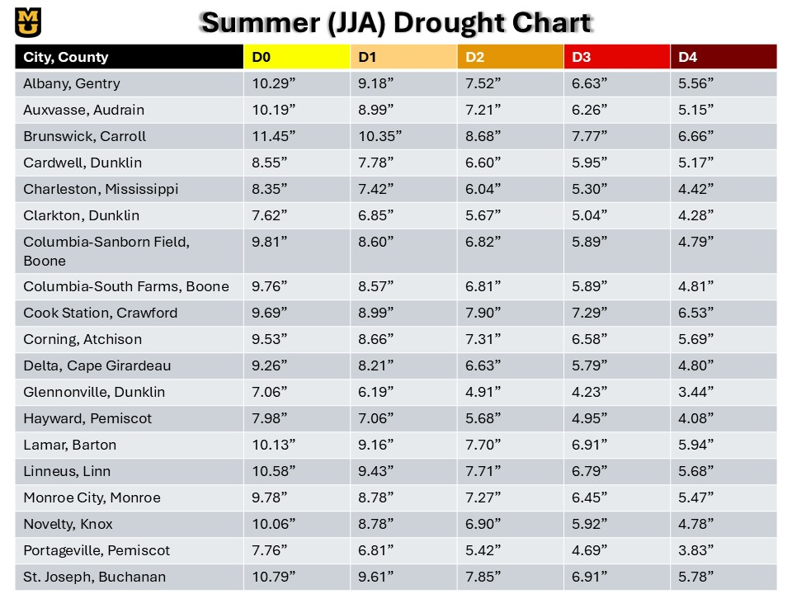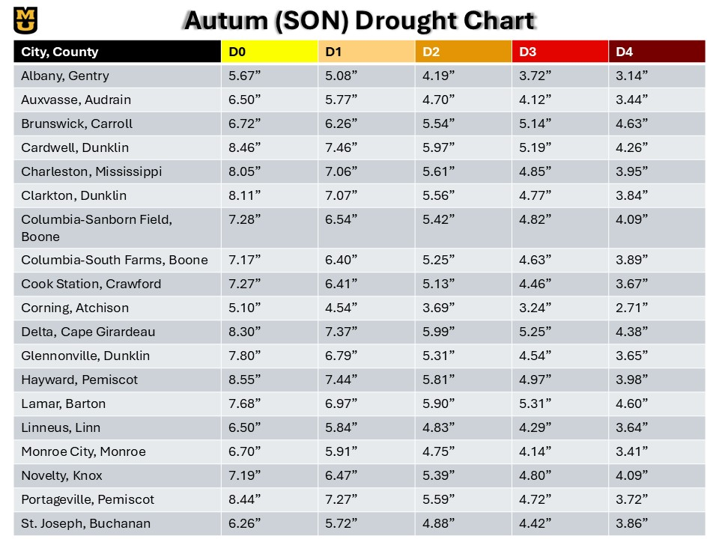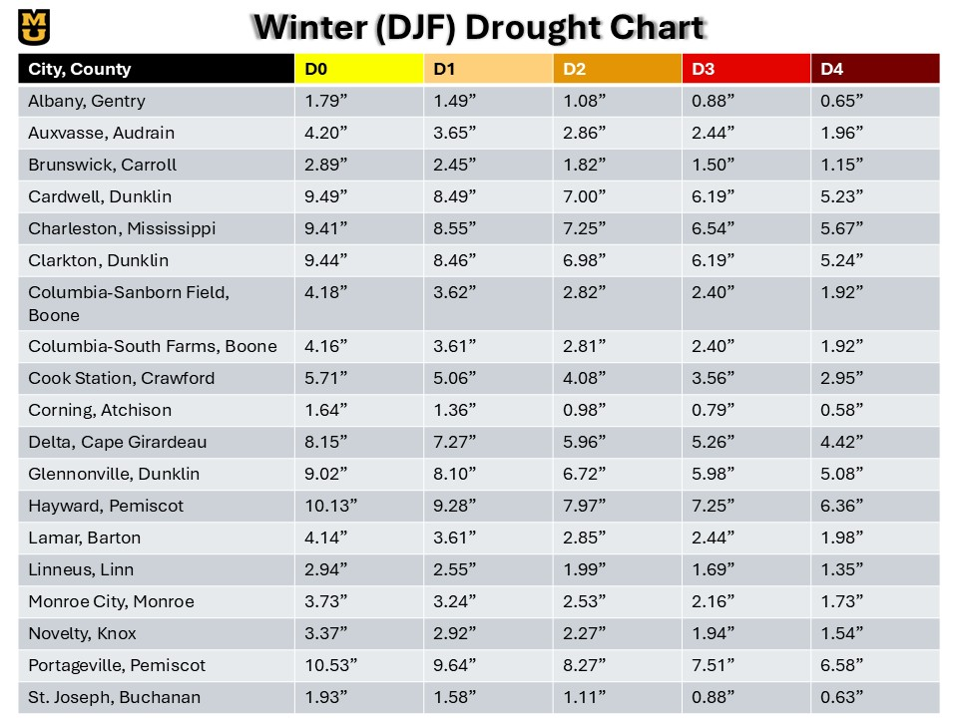

# Appendix C: Mesonet Station Summaries

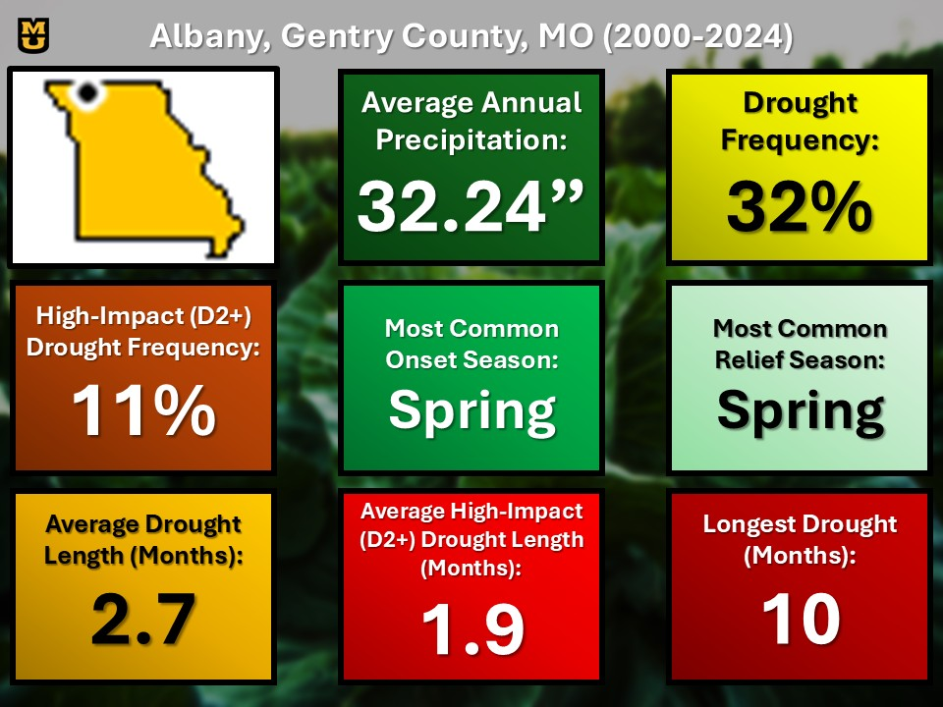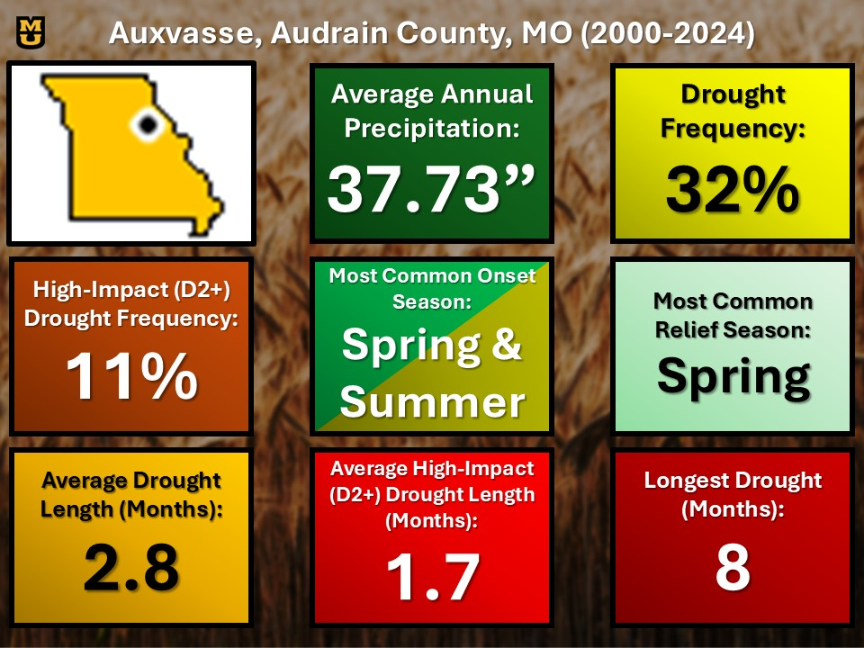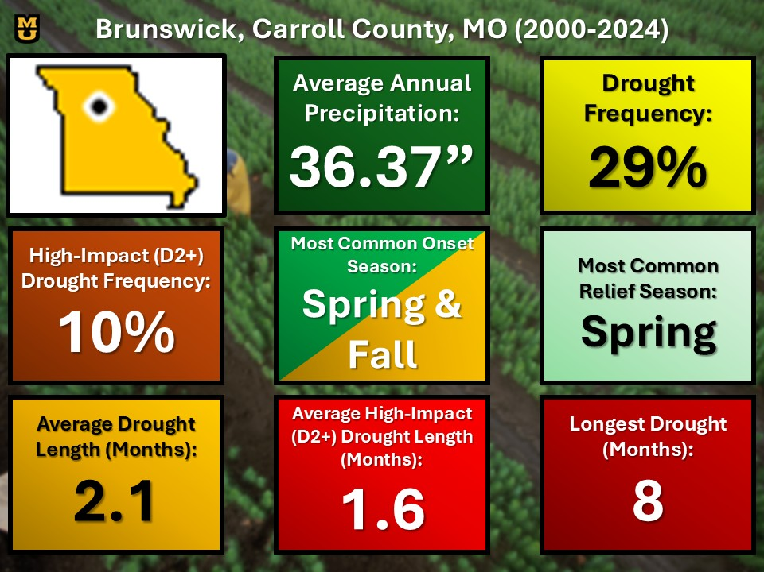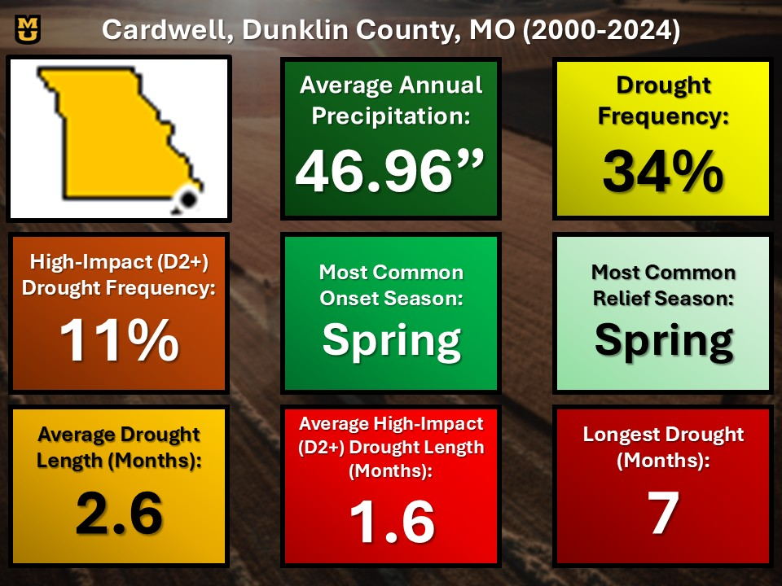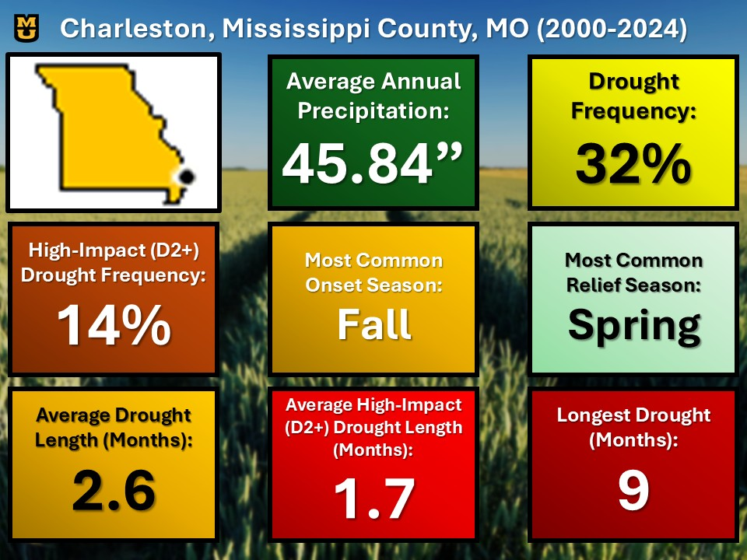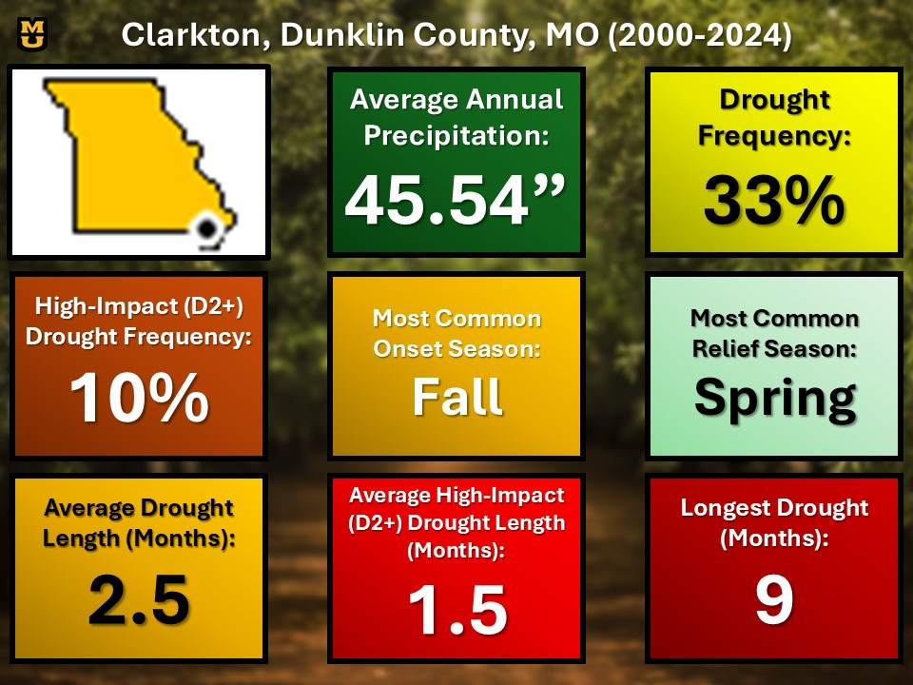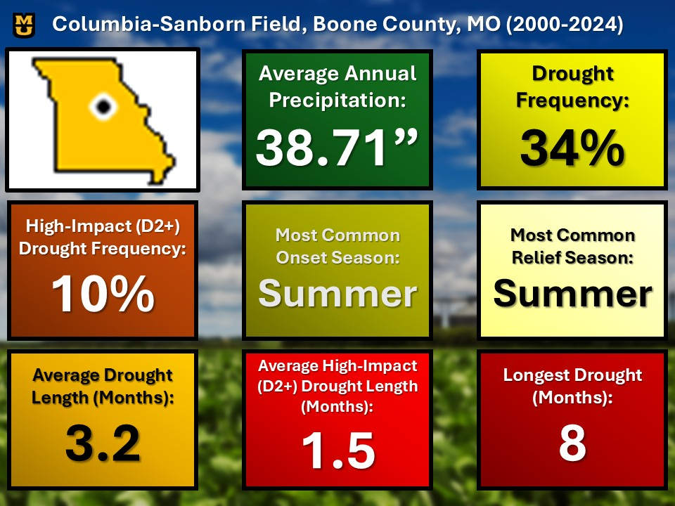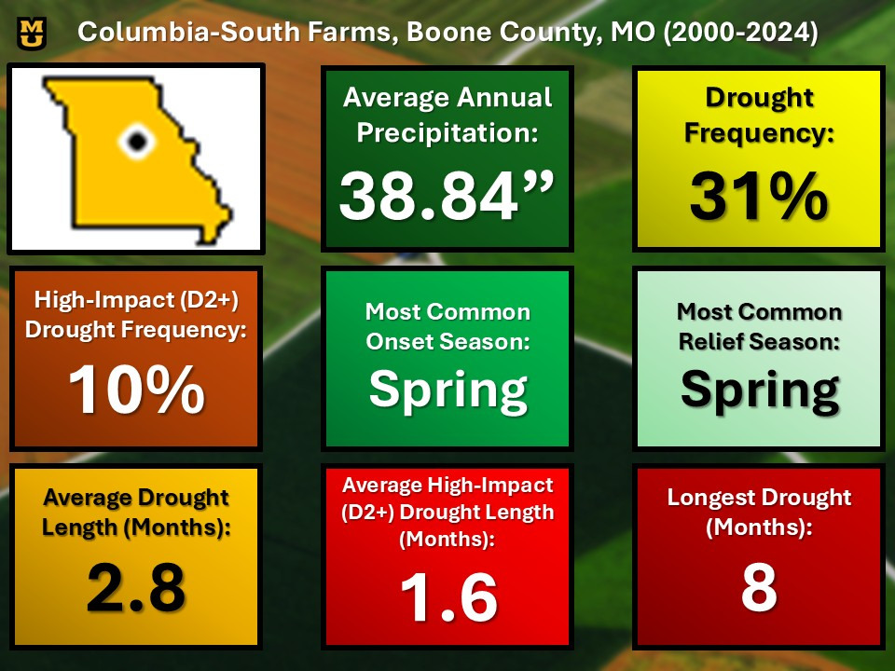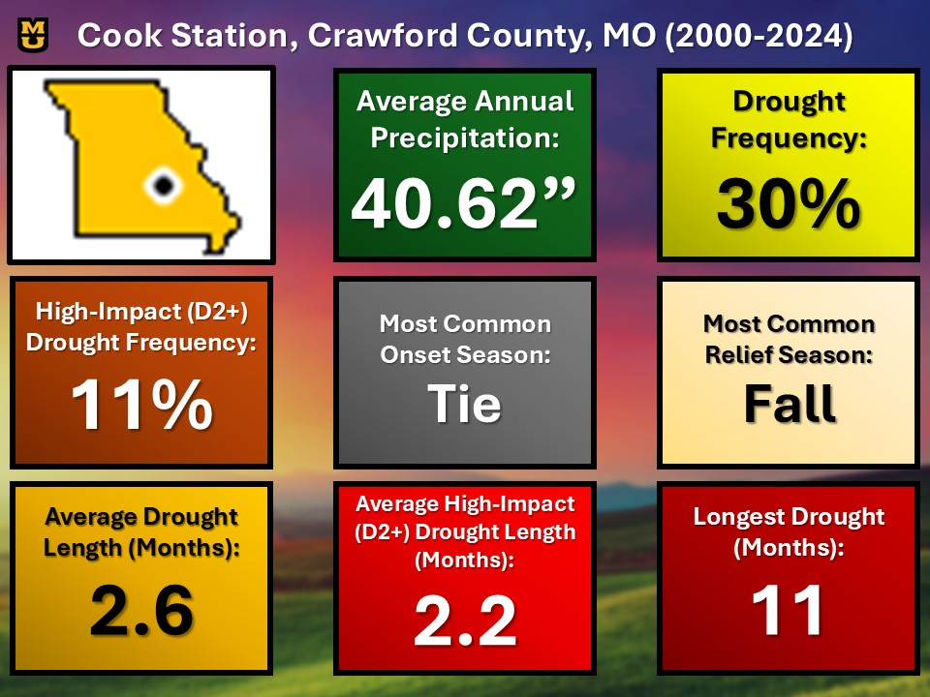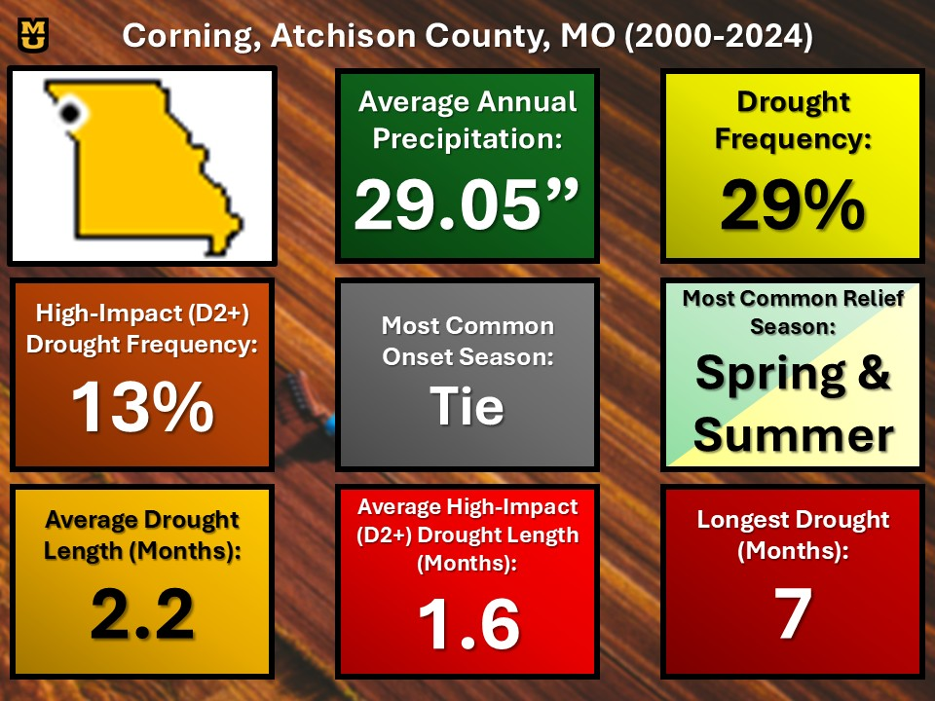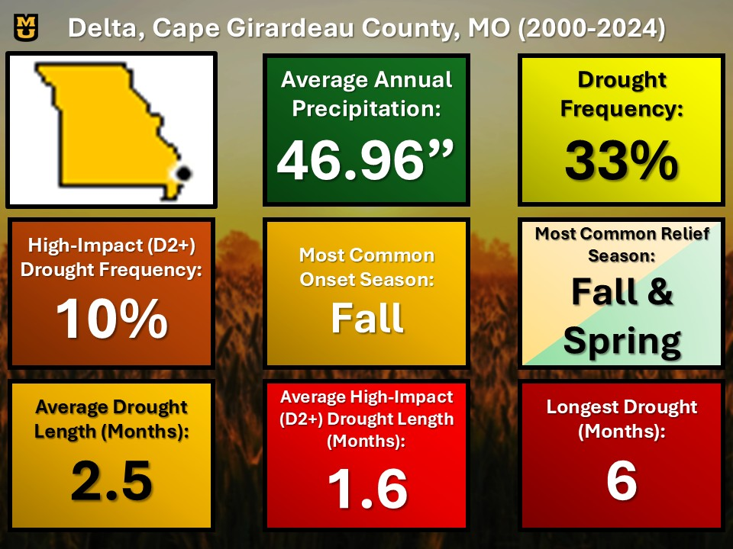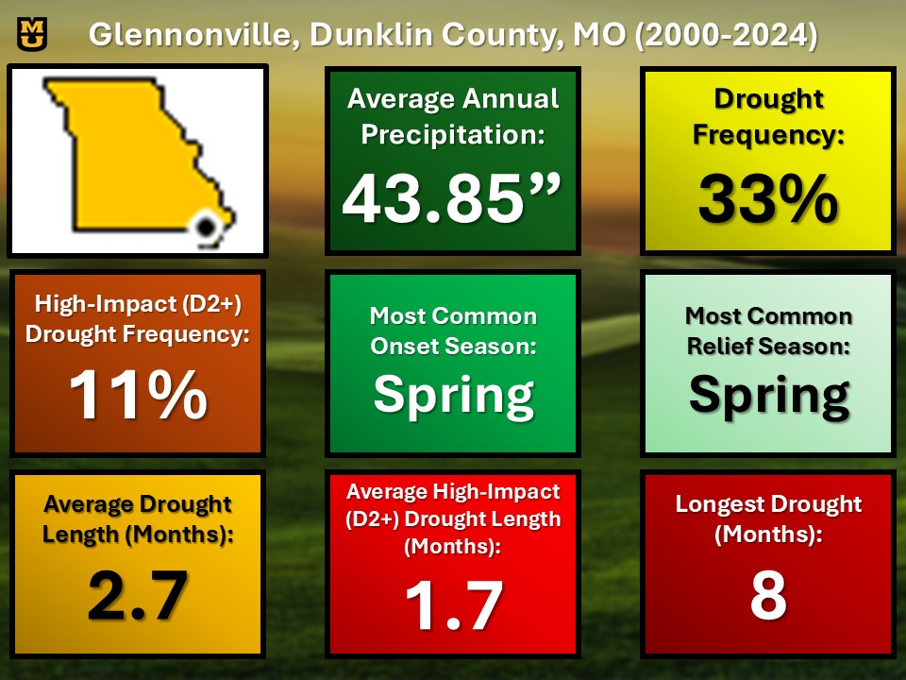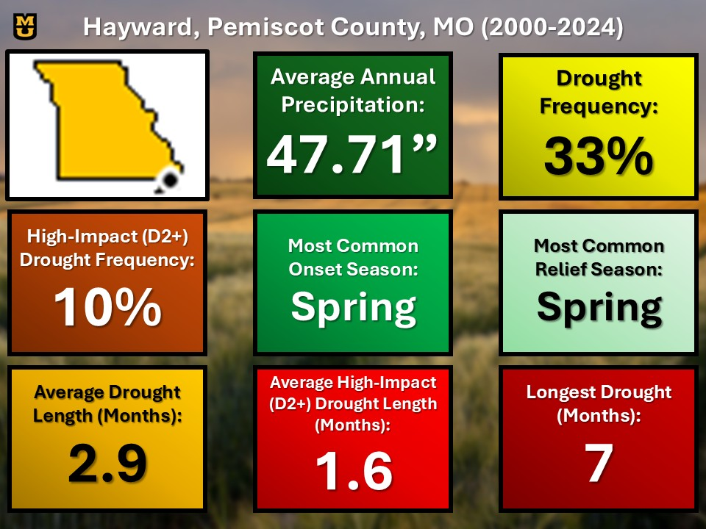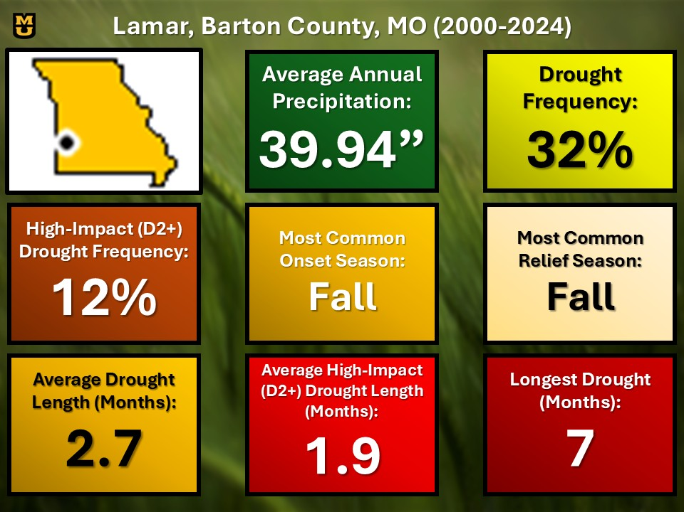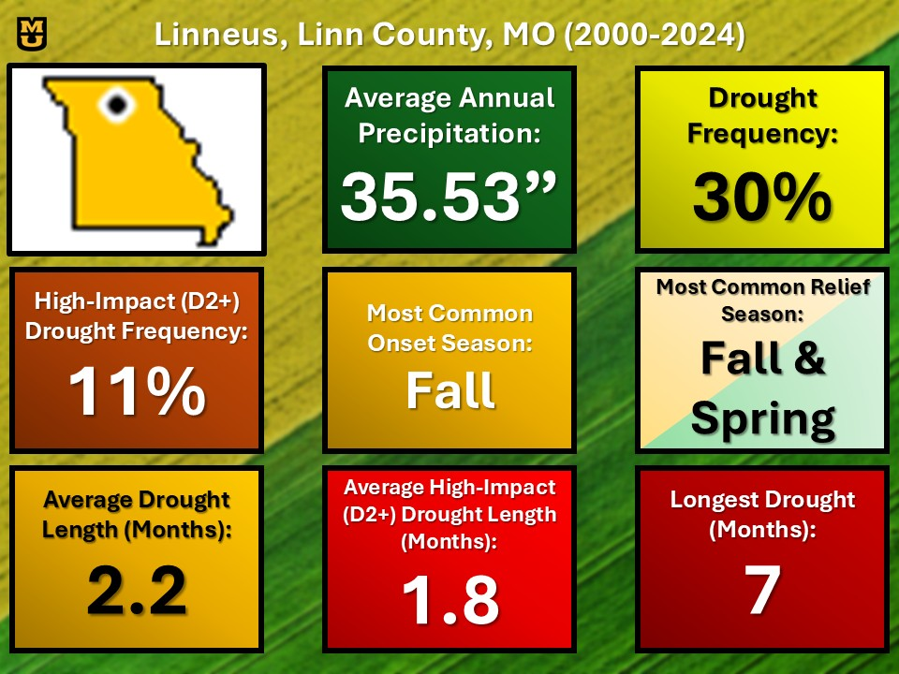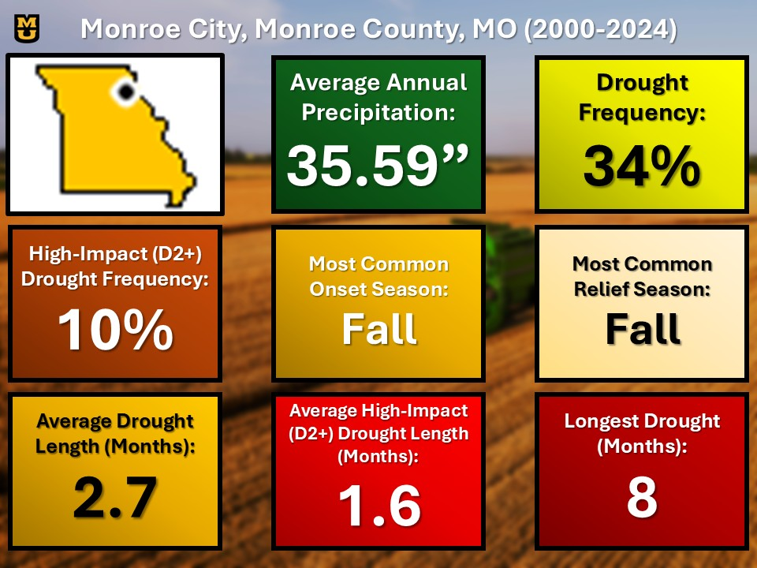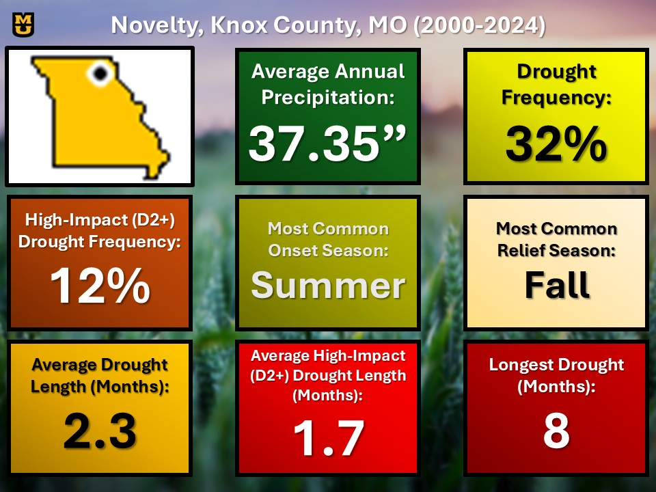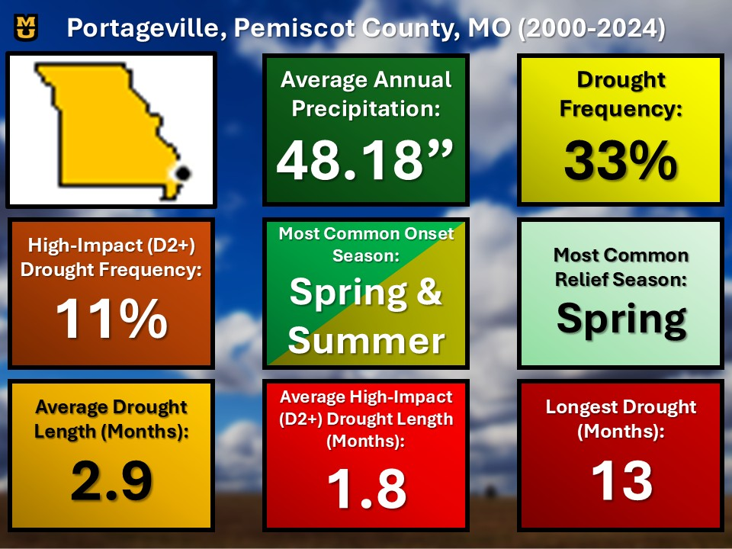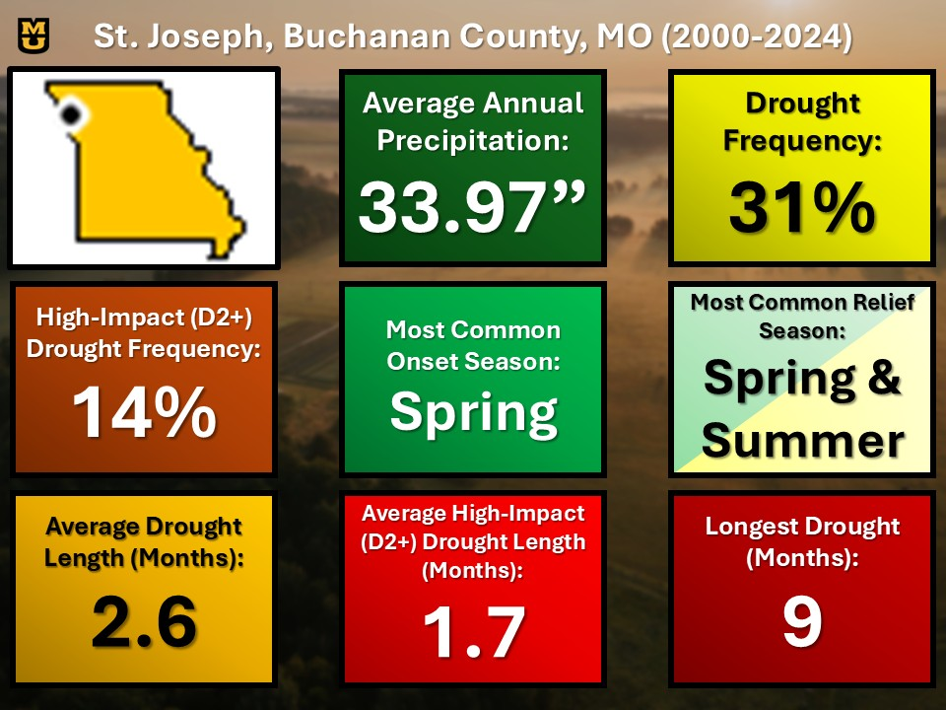

# Appendix D: Works Cited

The Editors of Encyclopedia Britannica. (2025, May 9). *Microclimate*. Encyclopædia Britannica. https://www.britannica.com/science/microclimate

McKee, T. B., Doesken, N. J., & Kleist, J. (1993). The Relationship of Drought Frequency and Duration to Time Scales. *Eighth Conference on Applied Climatology*, 179–184.

Merriam-Webster. (n.d.). Drought. In Merriam-Webster.com dictionary. Retrieved September 22, 2025, from https://www.merriam-webster.com/dictionary/drought

Merriam-Webster. (n.d.-a). *Correlation definition & meaning*. https://www.merriam-webster.com/dictionary/correlation

Merriam-Webster. (n.d.-b). *Variance definition & meaning*. Merriam-Webster. https://www.merriam-webster.com/dictionary/variance

National Drought Mitigation Center. (n.d.-a). *Drought classification*. Drought Classification | U.S. Drought Monitor. https://droughtmonitor.unl.edu/About/AbouttheData/DroughtClassification.aspx

National Drought Mitigation Center. (n.d.-b). *SPI Map Interpretation*. SPI Map Interpretation | National Drought Mitigation Center. https://drought.unl.edu/Monitoring/SPI/MapInterpretation.aspx

National Integrated Drought Information System. (n.d.). *Drought early warning*. Drought.gov. https://www.drought.gov/about/drought-early-warning

National Oceanic and Atmospheric Administration. (2024, February 27). *Meteorological and astronomical seasons | National Oceanic and Atmospheric Administration*. Infographic: Meteorological and astronomical seasons . https://www.noaa.gov/education/multimedia/infographic/infographic-meteorological-and-astronomical-seasons

NOAA National Centers for Environmental Information. (2025). *Billion-dollar weather and climate disasters*. Billion-Dollar Weather and Climate Disasters | National Centers for Environmental Information (NCEI). https://www.ncei.noaa.gov/access/billions/

US Department of Commerce, N. (2018, March 27). *Drought types*. National Weather Service. https://www.weather.gov/safety/drought-types

Wilhite, D. A., & Glantz, M. H. (1985). Understanding: The drought phenomenon: The role of definitions. *Water International*, *10*(3), 111–120. https://doi.org/10.1080/02508068508686328

World Meteorological Organization. (2023). *Guide to climatological practices - WMO library*. https://library.wmo.int/doc_num.php?explnum_id=5541